Perspectives and Their Implications: Riding the Wave of Human Connection
Unit by Edith Middleton

Lesson 1

Lesson Objective and Essential Question
How do cultural experiences shape or influence our identity and perceptions?
Students analyze a particular point of view or cultural experience reflected in a work of literature from outside the United States.
Warm-up
Teacher prompts students to consider:
- What is perspective, and why is it important?

Think about the following made up prompt:
- Your high school is considering extending the school day by two hours. Who should a journalist interview in order to get an accurate understanding of the pros and cons of this proposition?
Focus text(s) / resource(s) for today’s lesson
Video: Why should you read Shakespeare’s “The Tempest”? - Iseult Gillespie

Worksheet:
- The Tempest L1-ANTICIPATION GUIDE QUESTIONS [.pdf]
- The Tempest L1-ANTICIPATION GUIDE QUESTIONS [.docx]
Lesson / Activities
1. Individually or in small groups, students brainstorm responses to the following questions, based on the warm-up prompt:

- What would the journalist be missing if they interviewed only teachers? Or only students?
- How does a student's perspective differ from a teacher's perspective? Why?
- What are the potential consequences of ignoring a particular perspective, or giving too much voice to one group of people?

2. Students post answers to Jamboard under each question (see example below).
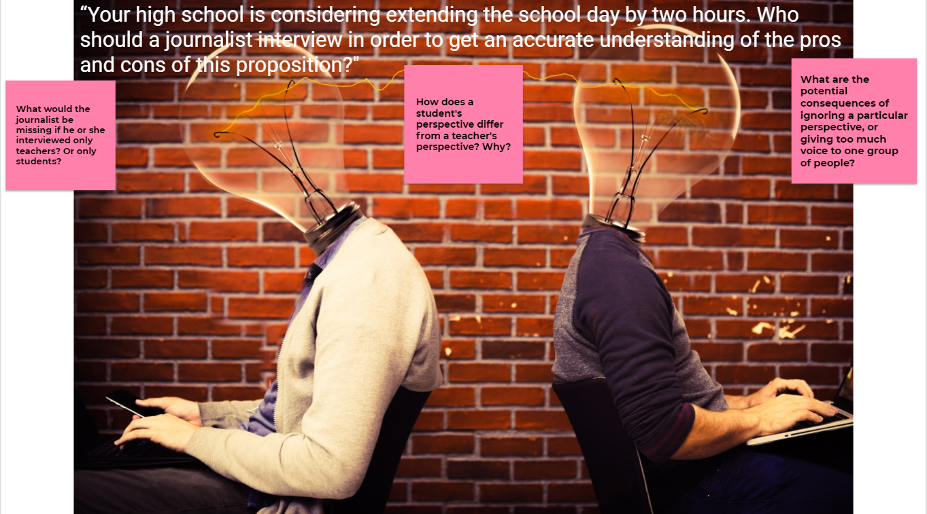
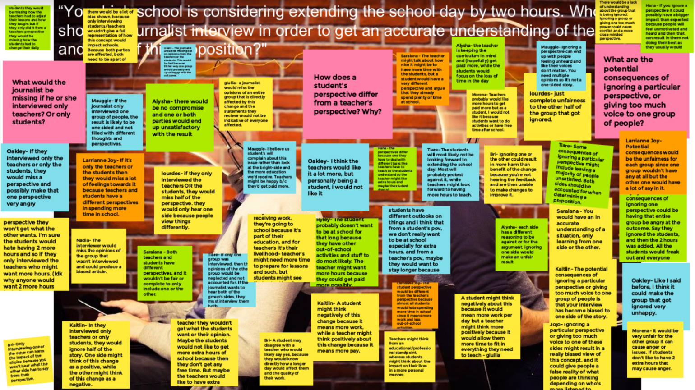
3. Individuals/small groups share answers and participate in a whole class discussion about perspective and its importance.

4. Teacher introduces William Shakespeare’s play The Tempest with this resource:
- “Why should you read Shakespeare’s The Tempest?” - Iseult Gillespie

5. Students work individually/in pairs/in small groups to complete the anticipation guide questions for Lesson 1.
Homework
1. Start looking for your Independent Reading (IR) choice
- Post your choice to class IR Padlet under your name (this column will house all your IR posts for the duration of the unit)
  - 1️⃣ Post the Name & Author of your novel as the title.
  - 2️⃣ Add a link to a summary of your chosen novel. (Goodreads, Amazon, etc.)
  - 3️⃣ Write a brief explanation:
    - 📌 Why did you choose this novel?
    - 📌 What is the perspective?
    - 📌 What are the implications of this perspective?

2. End of Week EXIT Post
- What is perspective, and why is it important?
- What are you apprehensive about in this unit?
- What are you looking forward to?

3. Finish The Tempest L1-ANTICIPATION GUIDE QUESTIONS

Click here for an example of a completed anticipation guide questions worksheet from a student in Edith Middleton’s spring 2021 class.

Lesson 2

Lesson Objective and Essential Question
How do cultural experiences shape or influence our identity and perceptions?
Students analyze a particular point of view or cultural experience reflected in a work of literature from outside the United States.
Warm-up
1. Teacher prompts students to share:
- What did we remember or learn about Shakespeare in our last class?

2. Students share insights from Anticipation Guide homework.
Focus text(s) / resource(s) for today’s lesson
Text: No Fear Shakespeare version of The Tempest by William Shakespeare
- Available online: https://www.sparknotes.com/nofear/shakespeare/tempest/page_2/

Worksheet:
- The Tempest ACT I Reader Response Questions [.pdf]
- The Tempest ACT I Reader Response Questions [.docx]
Lesson / Activities
In-class reading of The Tempest, ACT I
- https://www.sparknotes.com/nofear/shakespeare/tempest/page_2/

1. Teacher writes names of ACT I characters from The Tempest on the board.

2. Students volunteer and sign up to read specific character parts.

3. Whole class reading of ACT I. Students have the option to read the original or the translated version.

(See example whiteboard from Edith Middleton’s class below.)
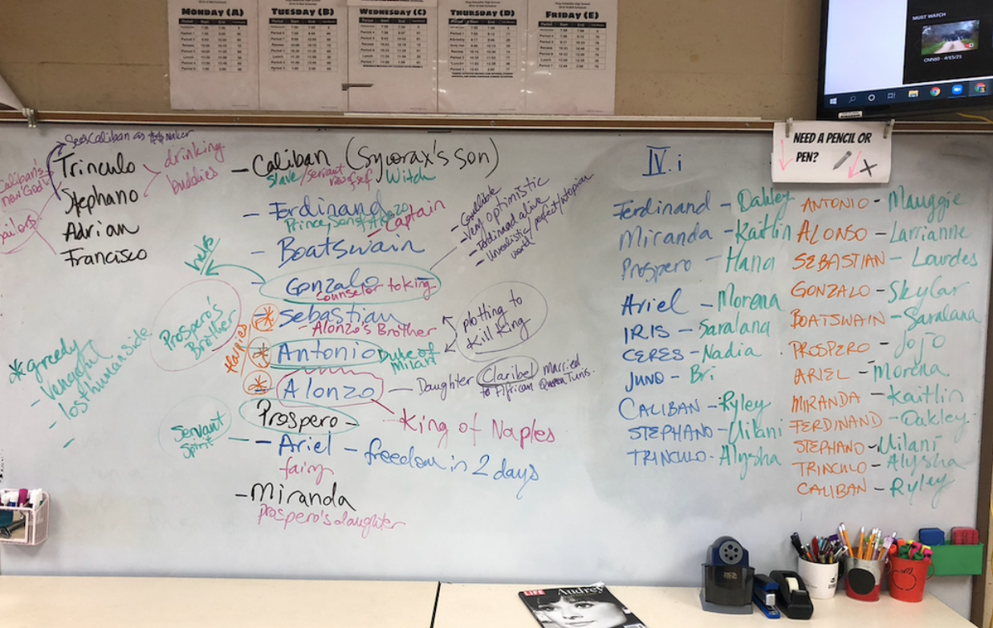
Closing and Homework
Closing:

Teacher prompts students in whole class discussion:
- From what we learn in ACT I, how has Prospero's migration changed him? Think about who he was in Milan, what he valued, versus who he seems to be now.

Students post ACT I prompt discussion takeaway and response to Padlet.

Homework:

1. The Tempest ACT I Reader Response Questions

Click here for an example of completed ACT I Reader Response Questions by a student in Edith Middleton’s spring 2021 class.

2. Select your Independent Reading (IR) Project. These are your options:
- Literary Elements PowerPoint
- 3D Quotes Project
- Book Trailer

Post your IR Project choice to class IR Padlet under your name (this column will house all your IR posts for the duration of the unit)
- 1️⃣ Post your IR project choice as the title.
- 2️⃣ Add a link to the doc you will be using for the project.
- 3️⃣ READ your IR book for 20 min each day this week!

Lesson 3

Lesson Objectives and Essential Question
Analyze a particular point of view or cultural experience reflected in a work of literature from outside the United States.
Cite strong and thorough textual evidence to support analysis of what the text says explicitly as well as inferences drawn from the text, including determining where the text leaves matters uncertain.
Warm-up
1. Teacher prompts students to share:
- Who did we meet in ACT I and what did we learn about these characters?
- What do you think will happen in today’s readings?

2. Students share insights from ACT I Reader Response Questions and anticipatory reactions of ACT II & III.
Focus text(s) / resource(s) for today’s lesson
Text: No Fear Shakespeare version of The Tempest by William Shakespeare
- Available online https://www.sparknotes.com/nofear/shakespeare/tempest/page_2/

Worksheet:
- The Tempest ACT II & III Reader Response Questions [.pdf]
- The Tempest ACT II & III Reader Response Questions [.docx]
Lesson / Activities
In Class Reading of The Tempest, ACT II & III
- https://www.sparknotes.com/nofear/shakespeare/tempest/page_2/

1. Teacher writes names of ACT II & III characters from The Tempest on the board .

2. Students volunteer and sign up to read specific character parts.

3. Whole class reading of ACT II & III - students have the option to read the original or the translated version.

4. After ACT II: Teacher prompts students in whole class discussion:
- Think about how characters behave in ACT II and your knowledge from our learning about identity and culture this year. What could Shakespeare be saying about human nature?

5. After ACT III:
Teacher prompts students in whole class discussion:
- As we reach the climax of The Tempest, how does Shakespeare use human connection to highlight themes in the play?
Closing and Homework (if any)
Closing:

Students post ACT II & III prompt discussion takeaway and response to Padlet

Homework:

1. The Tempest ACT II & III Reader Response Questions

2. Start building your Independent Reading (IR) Project on the document attached to class IR Padlet.
- READ your IR book for 20 min each day this week!

Lesson 4

Lesson Objectives and Essential Question
Consider how canonical literature may position white characters in relation to those of different races and ethnicities.
Cite strong and thorough textual evidence to support analysis of what the text says explicitly as well as inferences drawn from the text, including determining where the text leaves matters uncertain.
Warm-up
1. Teacher prompts students to share:
- What are some of the ways that characters behave? Would they act differently if they chose to voyage to the island versus the perceived shipwreck?
- What do you think will happen in today’s readings?

2. Students share insights and anticipatory reactions to finishing the play.
Focus text(s) / resource(s) for today’s lesson
Text: No Fear Shakespeare version of The Tempest by William Shakespeare
- Available online https://www.sparknotes.com/nofear/shakespeare/tempest/page_2/

Worksheet:
- The Tempest ACT IV-V Reader Response Questions [.pdf]
- The Tempest ACT IV-V Reader Response Questions [.docx]
Lesson / Activities
In Class Reading of The Tempest, ACT IV & V
- https://www.sparknotes.com/nofear/shakespeare/tempest/page_2/

1. Teacher writes names of ACT IV & V characters from The Tempest on the board.

2. Students volunteer and sign up to read specific character parts.

3. Whole class reading of ACT IV & V. Students have the option to read the original or the translated version.

4. After ACT IV:
Teacher prompts students in whole class discussion:
- Why does the masque suddenly disappear when Prospero remembers the plot against him by Caliban and his crew? What is Shakespeare suggesting by contrasting these two events?

5. After ACT V:
Teacher prompts students in whole class discussion:
- How does Shakespeare use catharsis to shed light on moral obligations and human connection that highlight themes in the play? (What specific themes are highlighted?)
Closing and Homework (if any)
Closing:

Students post ACT IV & V prompt discussion takeaway and response to Padlet.

Homework:

1. The Tempest ACT IV-V Reader Response Questions

2. Continue building your Independent Reading (IR) Project on the document attached to class IR Padlet.
- READ your IR book for 20 min each day this week!

Lesson 5

Lesson Objective and Essential Question
Consider how canonical literature may position white characters in relation to those of different races and ethnicities.
Analyze the impact of specific word choices on meaning and tone.
Warm-up
1. Teacher prompts students in whole class discussion:
- What perspectives were provided in The Tempest? What could be some reasons for why Shakespeare chose to write the play from these perspectives?

2. Students examine authors' perspectives and the potential implications of those perspectives.
Focus text(s) / resource(s) for today’s lesson
Text with worksheet (used in class):
- The Narrative of the Captivity and Restoration of Mrs. Mary Rowlandson [.pdf]
- The Narrative of the Captivity and Restoration of Mrs. Mary Rowlandson [.docx]

Videos (used for homework):
- The Danger of a Single Story by Chimamanda Ngozi Adichie
- Olive Oatman: Life among the Mohave
Lesson / Activities
1. Students work individually/in pairs/small groups to read and accurately locate Mary Rowlandson's perspective in the excerpts from The Narrative of the Captivity and Restoration of Mrs. Mary Rowlandson to analyze word choice, and to discuss how these choices impact meaning and tone.

2. Discuss and analyze the text using the guiding questions as a class:
- How are white people portrayed in this text?
- How are Native Americans portrayed?
- What words stand out to you as you read?
- What details seem important?

Click here for an example of an annotated version of the Mary Rowlandson text/worksheet by a student in Edith Middleton’s spring 2021 class.

3. Teacher prompts students in whole class discussion:
- What can we learn about Rowlandson's understanding of the "Indians" and herself through this close analysis?
- How do you imagine this text would be different if it were written from the perspective of the Native Americans who she encounters?
Closing and Homework
Closing:

Students post prompt discussion takeaway and response to Padlet

Homework:

1. Use the following worksheet to complete this homework activity:
- Worksheet: Blue Tattoo and Single Story [.pdf]
- Worksheet: Blue Tattoo and Single Story [.docx]
- Watch the short biography of Olive Oatman: Life among the Mohave
- Watch The Danger of a Single Story by Chimamanda Ngozi Adichie
  - What is a "single story"? Who tells these "single stories?"
  - What did Adichie's roommate believe about Africa and people who live in Africa? Why?
  - What does Adichie say about her understanding of immigration in the United States? Why does she give this example?
  - Make a connection between Adichie's discussion and Mary Rowlandson's captivity narrative.

Click here and here for two examples of completed Blue Tattoo and Single Story worksheets by students in Edith Middleton’s spring 2021 class.

2. Continue building your Independent Reading (IR) Project on the document attached to class IR Padlet.
- READ your IR book for 20 min each day this week!

Lesson 6

Lesson Objective and Essential Question
Question the positive and negative perspectives of migration and its similarities and differences on those affected.
Discuss how Pulitzer Center stories shed light on Perspectives and Human Connections.
Warm-up
1. Teacher prompts students in whole class discussion:
- How has migration and movement affected characters in The Tempest?
- What are some similarities and differences of how migration and movement affected characters in other texts from this unit?
Focus text(s) / resource(s) for today’s lesson
Texts:
- Repairing Broken Bonds: How Families Rebuild Ties After Migration
- Alone in a Pandemic
- Beijing's Rat Tribe: The Chinese Dream Goes Underground
- Intersex, and Proud
- Abby Dreams of Space
- Women on the Move
- A Teenager Starting Over in Canada
- Life After Deportation

Worksheet:
- Perspective and Human Connections: Pulitzer Center Stories [.pdf]
- Perspective and Human Connections: Pulitzer Center Stories [.docx]
Lesson / Activities
1. Teacher introduces summative performance task options for students to evaluate and vote:
- Socratic Seminar (completed as a collective with individual question preparation)
- Editorial Essay or Short Film (completed individually)

2. Students evaluate the assignment options and cast vote.

3. Teacher prompts students in whole class discussion:
- Think back to Rowlandson's text. How did she portray the "Indians" and why?
- Why might it be important to investigate the perspective of the Native Americans that she described?
- In Shakespeare's text, whose perspective are we getting? With what characters are we as readers able to sympathize? What characters seem like us?
- In Shakespeare's text, why does Prospero feel compelled to whip Caliban? What does Prospero claim that he has given to Caliban?
Closing and Homework
Closing:

Students post prompt discussion takeaway and response to Padlet - End of Week EXIT Post.

Click here to see Padlet responses from students in Edith Middleton’s spring 2021 class.

Homework:

1. Complete Perspectives and Human Connections: Pulitzer Center Stories worksheet.

Click below for four examples of Perspectives and Human Connections worksheets completed by students in Edith Middleton’s spring 2021 class.
- Student example 1
- Student example 2
- Student example 3
- Student example 4

2. Finish building your Independent Reading (IR) Project and attached to class IR Padlet
- Use the + and add as follows:
  - 📌 Title: IR Project
  - 📌 Attach your Final, clean and ready to present, IR Project with open share settings!
  - 📌 Change Final Project post color to RED :)

Lesson 7
Lesson Objectives
Explore literary and Pulitzer Center journalistic texts to expand understanding of how perspective, identity, and authorship shape texts and perspectives on migration.
Question the positive and negative perspectives of migration and its similarities and differences on those affected.
Warm-up
Teacher prompts students in whole class discussion:
- How has migration and movement affected characters in The Tempest?
- What are some similarities and differences of how migration and movement affected characters in other texts from this unit?
Focus text(s) / resource(s) for today’s lesson
Videos (for use if students voted to do the Socratic Seminar):
- How to do the Socratic Method
- The Guide to Socratic Seminars

Worksheets/handouts:
- Socratic Seminar performance task preparation packet
  - Discussion questions for The Tempest to brainstorm and prepare
- Editorial Essay or Short Film Performance Task Descriptions
  - Editorial Essay performance task preparation packet [.pdf]
  - Editorial Essay performance task preparation packet [.docx]
  - Short Film performance task preparation packet [.pdf]
  - Short Film performance task preparation packet [.docx]
Lesson / Activities
Teacher introduces the summative performance task selected by the class in Lesson 6 and students begin to work through preparation packets.

In-class preparation for Socratic Seminar Performance Task

1. As a class, students watch and discuss the following videos about Socratic Seminar:
- How-to
- A guide to socratic seminar

2. The teacher projects a Jamboard and scribes as students create Socratic Seminar Norms and Guiding Question.

(See example of completed Jamboard below.)

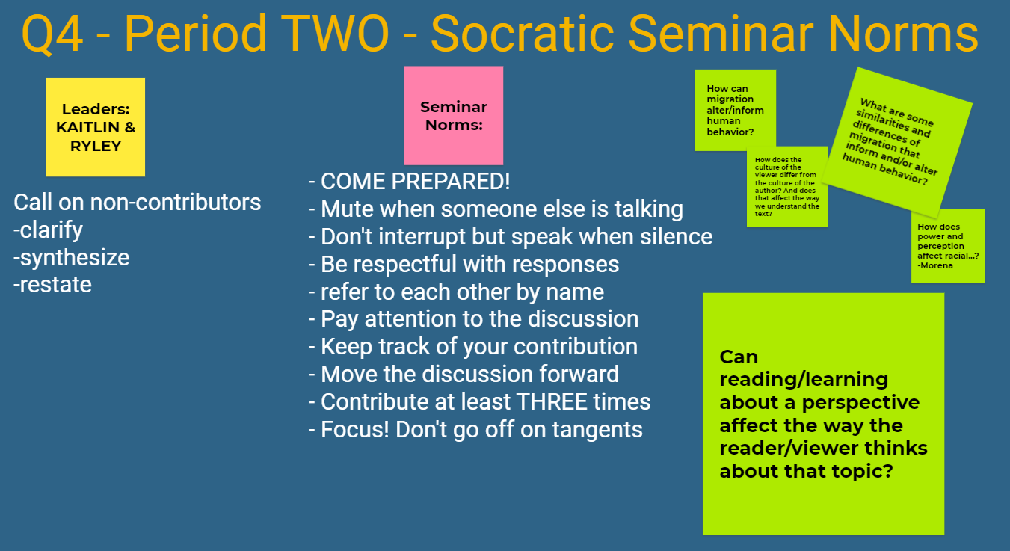

4. Teacher explains and guides students through the Socratic Seminar Preparation Packet and as a class, students brainstorm sample questions while the teacher scribes for students.

In-class preparation for Editorial Essay or Short Film Performance Task
1. Students review the assignment options and requirements for Editorial Essay or Short Film Performance Task Options and declare assignment choice.

2. Teacher assigns the students’ selected assignment choices on Google Classroom; either the Editorial Essay Performance Task or the Short Film Performance Task assignment.
Closing and Homework (if any)
Closing:

1. Individually, students work on Summative Performance Task assignment
- Socratic Seminar Preparation Packets to brainstorm questions using sample questions
- Editorial Essay or Short Film preparation packets

2. Students post prompt discussion takeaway and response to End of Week EXIT Post Padlet:
- (Classes with Socratic Seminar) How did the Pulitzer Center stories you chose shed light on Perspectives and Human Connections? Share the name of the stories as part of your response. **DON’T FORGET to post & reply.
- (Classes with Editorial Essay or Short Film) Reflect on your planning for your Tempest assignment. ** DON'T FORGET to post & reply
  - 📌 What's going well?
  - 📌 What are you struggling with?
  - 📌 What's your goal for this assignment? (other than to finish it?)

Homework:

1. Complete Socratic Seminar Preparation Packets / Editorial Essay or Short Film Graphic Organizer
2. Sign up for a time to present your Independent Reading (IR) Project

Lesson 8
Lesson Objectives
Question the positive and negative perspectives of migration and its similarities and differences that inform or alter human behavior.
Explore literary and Pulitzer Center journalistic texts to expand understanding of how perspective, identity, and authorship shape texts and perspectives on migration.
Warm-up
1. Teacher checks in with students:
(Classes with Socratic Seminar) How did the Pulitzer Center stories you chose shed light on Perspectives and Human Connections? Share the name of the stories as part of your response.
- Review of Socratic Seminar norms

(Classes with Editorial Essay or Short Film) How is your planning for your performance task assignment coming along?
  - 📌 What's going well?
  - 📌 What are you struggling with?

Focus text(s) / resource(s) for today’s lesson
Worksheets/handouts:
- Socratic Seminar performance task preparation packet [.pdf]
- Editorial Essay performance task preparation packet [.pdf]
- Editorial Essay performance task preparation packet [.docx]
- Short Film performance task preparation packet [.pdf]
- Short Film performance task preparation packet [.docx]
Lesson / Activities
Socratic Seminar Performance Task

1. Students begin the Socratic Seminar, student leaders monitor questions and discussion.

2. The teacher monitors the seminar and communicates with the student leaders via private chat.

Editorial Essay or Short Film Performance Task

1. Teacher checks in with individual students about chosen assignments and progress.

2. Teacher conferences individually with students who chose the short film assignment.

3. Students work individually to finish rough drafts of editorial essays and meet for five-ten minute one on one conferences with the teacher before moving onto the final draft.
Closing and Homework (if any)
Closing:

Socratic Seminar Performance Task
Students complete Socratic Seminar Self Evaluation in their L7 - Socratic Seminar Preparation Packet and turn in on Google Classroom.
- Socratic Seminar Preparation & Participation Rubric

Editorial Essay or Short Film Performance Task
Students turn in final clean error free Final Draft Essays/Final Cut Films on Google Classroom.
- Editorial Essay & Short Film Explanatory/Informative Rubric

Homework:

Students prepare to present their Independent Reading (IR) Summative Project, Literary Elements PowerPoint, 3D Quotes Project, or Book Trailer.

