Glocalization: Writing Feature Stories on Family Migration
Unit by Donna Torres

Day 1

Lesson Objectives
Goals: Students will be able to…

- Make local/personal connections to a global issue
- Explore the definition of migration/immigration.
- Learn about migration and current issues
Warm-up
- Define the term global issue.
- Reflect on how global issues influence our lives.
- Choose one global issue (such as migration, climate change, or racial justice) and explain: How does this global issue influence your life and/or your community?
Focus text / Resource for today’s lesson
Excerpts: from “What Migrants Face as They Journey Through the Deadly Darien Gap” by Nadja Drost and Bruno Federico for PBS NewsHour
Lesson / Activities
Today and throughout our unit, we will make local/personal connections to the global issue of migration.

1. Respond to the following question in 1-3 sentences: What is the difference between a migrant and an immigrant?

2. Use a Jamboard to share your responses to the following question: Why do people leave their homes and travel to a new country or region?

3. Watch “What Migrants Face as They Journey Through the Deadly Darien Gap” by Nadja Drost and Bruno Federico. While you watch, keep track of what you learn about the following:

- Why do people leave their homes and travel to a new country or region?
- What problems/experiences do migrants face on their journeys?

3. Discuss: What problems/experiences do migrants face on their journeys?
Note to educator:

Regardless of which term is used, both migrant and immigrant describe living, breathing human beings—mothers and fathers, sisters and brothers, grandparents and grandchildren—all of whom have left one place in search of a better life in another place.

Migrant: A broad term that applies to an individual who willingly leaves home and moves from one place to another, most often in search of employment. This includes people who:

- Move from one region to another within the borders of their own country (internal migration); or
- Move from their country of birth to another country or countries.

Migrants are generally temporarily away from their home and can return home at any time if they so choose.

Immigrant: An individual who willingly leaves their country of origin and legally enters another country where they are granted permission to permanently resettle, thus qualifying them to work without restriction. Their reasons for wanting to resettle can be many:

- Longing for economic prosperity
- Seeking a better education
- Fulfilling a dream
- Reuniting with family.

Day 2

Lesson Objectives
Goals: Students will be able to…

- Explore migration stories of their choice from the Pulitzer Center
- Determine characteristics of a feature article and the benefits of using visual and multimedia components
- Select one feature article and complete graphic organizer
Warm-up
Is there a story of migration in your family? Write about this story, keeping the following questions in mind:

- Who in your family has moved?
- Where did they live before, and where do they live now?
- What was their experience like? How has it affected them and/or you?
Focus texts / resources for today’s lesson
- Structure and Format of a Feature Article graphic organizer [.pdf]
- Structure and Format of a Feature Article graphic organizer [.docx]
- “Coming to America: It's Not Like the Movie” by Francesca Bentley for Pulitzer Center
- “Repairing Broken Bonds: How Families Rebuild Ties After Migration” by Melissa Noel for NBC News
- “Living Parallel Lives: A Family Divided” by Jessica Prokop and Amanda Cowan for The Columbian
Lesson / Activities
1. Today, we will dig into the components of a feature article, and explore some examples. Review the following introducing to this type of news story:

A feature article is a news story that goes beyond the facts to weave in a narrative and tell a compelling story. A feature article differs from a breaking news story as it offers an in-depth look at a particular subject, current event, or location to audiences. A good feature story will keep the reader’s attention until the end, delivering a fleshed-out narrative and creating a lasting impression.

All feature story ideas require a deep level of research—like interviews with people close to the story or research into extensive background information on a place. Feature writers go behind the scenes and have a commitment to uncovering the big story beneath the facts.

2. Choose one of the following feature articles to read today:

- Coming to America: It's Not Like the Movie
- Repairing Broken Bonds: How Families Rebuild Ties After Migration
- Living Parallel Lives: A Family Divided

3. While you read your chosen feature article, use this graphic organizer to record and analyze the basic components of a feature article.

3. Discuss: What are some sources of information that the journalist used in the feature article you explored. (Examples could include...data from a research organization; first-hand stories from interviewees; legal documents or records; etc.)

Day 3

Lesson Objectives
Goals: Students will be able to…

- Understand the culminating task for this unit: My Personal Migration Story: Feature Article
- Develop positive identity awareness: Who Am I?
- Explain how cultural identity defines who we are
Warm-up
1. How does cultural identity define who we are? Add your responses to this question to a Jamboard! (For an example of responses from students in Donna Torres’ class in spring 2021, see below.)

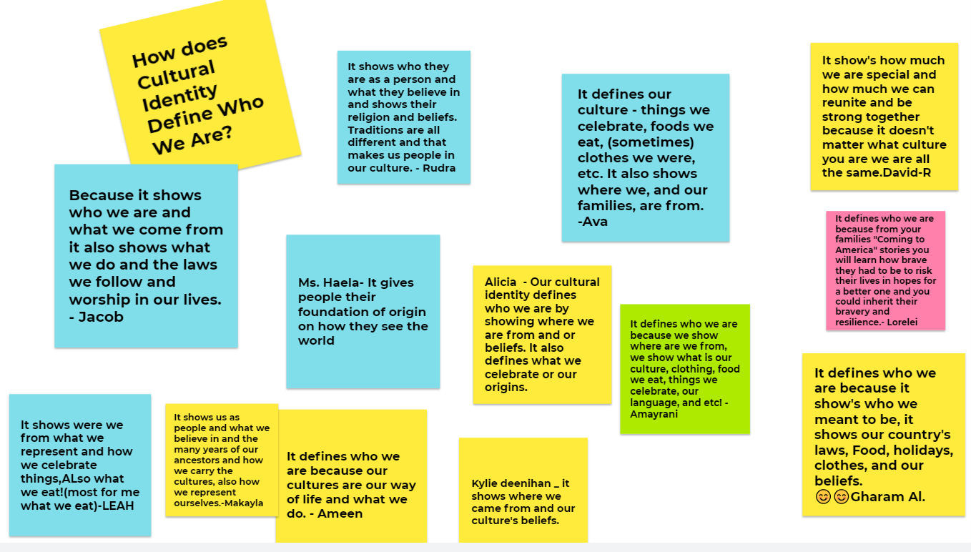

Note to educator: Cultural Identity passed on through family stories directly impacts how we see ourselves because they give us an idea of where we come from and how we fit into our family. Think of each family story as a single thread in a tapestry woven with beautiful, complex patterns, colors, and designs. Like a tapestry, we are a combination of the culture, history, and traditions we inherited from our own families.
Psychologists have found that sharing family stories contributes to kids’ emerging sense of self, both as an individual and as a member of a unified family. Adolescents who are able to recount specifics and details of family stories have higher self-esteem and greater resilience. Our family stories give us a sense of belonging and create a core identity that can be a great source of empowerment. Family stories bear witness to personal experiences and cultural history.
Focus texts / resources for today’s lesson
- “Collective Stories in Families Teach Us About Ourselves” by Dr. Robyn Fivush for Psychology Today
- “How Family Stories Shape Our Identities” by Rachel Coleman for FamilySearch Blog
Lesson / Activities
1. Select and read one of the following articles:

- Collective Stories in Families Teach Us About Ourselves
- How Family Stories Shape Our Identities

2. Respond to the following questions in writing after you read, then discuss with the class:

- How do family stories assist us in defining who we are?
- What are some experiences that help to form our identity?
- How does ethnic identity develop?

Notes: In addition to carving out a personal identity based on the need for uniqueness, people also acquire a social identity based on their membership in various groups—familial, ethnic, occupational, and others. These group identities, in addition to satisfying the need for affiliation, help people define themselves in the eyes of both others and themselves.
Homework
Discuss your project with your family to determine interview subjects.

Day 4

Lesson Objectives
Goals: Students will be able to…

- Develop interview questions
- Identify types of sources necessary to answer research questions
Warm-up
1. Imagine you are interviewing your teacher about their ancestry and any migration stories in their family. What questions would you ask to get the most information? Use a Jamboard to record your responses.
Focus text(s) / resource(s) for today’s lesson
- Writing Effective Interview Questions - lesson from Lumen Learning
- Journalist’s Toolbox: Conducting Interviews - video from the Pulitzer Center and Natasha S. Alford
Lesson / Activities
1. Review traits of effective interview questions. Interview questions should be: relevant, open-ended, clear, applicable, and unbiased.

2. Here are some tips to help you prepare to interview someone:

- Research their country of origin so you will be familiar with it. This will provide a resource for the types of interview questions you can ask.
- Compile a list of questions for your interview subject.
- Read other interviews or profiles of people where they discuss their migration experience. Notice what kinds of questions they're answering. This can help you get ideas, but can also help you think about what questions tend to get asked too often.
- Brainstorm specific questions that you feel the subject has never answered before. Ideally, a question should provoke a unique, thoughtful response.
- Think of open-ended questions that will make your interviewee speak at length on a subject. Not just answer yes or no!

3. For more tips on how to develop questions and conduct an interview, watch this video, featuring journalist Natasha S. Alford.

4. Independent work: Formulate interview questions for your chosen interviewee.

Day 5

Lesson Objective
Goal: Students will be able to develop an individual research plan
Warm-up
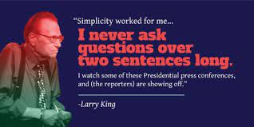
Larry King, an iconic TV interviewer, says, “I never ask questions over two sentences long.”

- Why is this good advice?
- What may occur if your questions are too long?
Focus text(s) / resource(s) for today’s lesson
- Research Plan graphic organizer [.pdf]
- Research Plan graphic organizer [.docx]
Lesson / Activities
1. Use this graphic organizer to develop a detailed research plan. Using the worksheet, students will:

- Finalize topics and interviewees
- Develop five to seven interview questions
- Identify sources for further research.
Closing and Homework (if any)
Students conduct their interviews and finalize an area of focus for their feature article. Students should record their interview (this can be done on a phone if the interview takes place in person, or through a free software such as Otter.ai if it takes place over the Internet). They should also take notes while they listen. Students should bring the recording and their notes to the next class period.

Day 6

Lesson Objectives
Students will be able to…

- Gather and analyze information from interviews
- Organize and synthesize information from interviews and other sources
Warm-up
Share with the class: What was the most interesting thing you found out from the interview you conducted?
Resource for today’s lesson
- Summary of Information from Interviews graphic organizer [.pdf]
- Summary of Information from Interviews graphic organizer [.docx]
- Structure and Format of a Feature Article graphic organizer [.pdf]
- Structure and Format of a Feature Article graphic organizer [.docx]
Lesson / Activities
1. Review the components of a feature article, which students identified using this graphic organizer on day 2. Students’ final articles should include all of these elements.

2. Spend some time with your interview recording and/or notes. Identify pull quotes that you can include in your article, using the far right column on this graphic organizer.

3. Students will spend the remainder of the class period working on their feature stories.

Days 7 & 8

Lesson Objective
Goal: Writers merge interviews and other sources into a first draft
Warm-up
Respond on a Jamboard: What have you learned about your ancestry, family culture, and identity in your interviews?
Lesson / Activities
1. Review the requirements for feature article projects as a class.
Write a feature article on “My Personal Migration Story.” Feature articles should…
- Examine a particular aspect of a topic in depth. (Articles should have a specific angle within the larger topic of migration.)
- “Feature” interesting people, places, events, activities, issues, and so on.
- Inform people first and foremost. They may additionally entertain and/or persuade.
- Use a variety of text features and multimedia components.
- Include supporting research using credible and accurate sources.
Content checklist:
- Topic and clear central idea
- Introduction that engages the reader and previews what is to follow
- Body organized into sections with headings
- Citations for credible research sources
- Transitions that create cohesion and clarify the relationships among ideas and concepts
- Conclusion that follows from and supports the information or explanation presented
- Formal style, precise language, and domain-specific vocabulary
- Graphics/images (charts, tables, maps, illustrations, photos, graphs, or other visual representations of information)
- Captions to explain graphics
2. Writing time: Continue working on feature article drafts.

Day 9

Lesson Objective
Goal:

- Writers add text features and multimedia elements to their articles.
- Students complete peer evaluations and incorporate feedback into their writing.
Focus text(s) / resource(s) for today’s lesson
- Students’ draft feature articles
- Self/Peer Evaluation Worksheet [.pdf]
- Self/Peer Evaluation Worksheet [.docx]
Lesson / Activities
1. Students use this evaluation worksheet to offer peer review feedback to at least one classmate, and also to evaluate their own work.

2. Students continue writing, revising, and adding multimedia elements.
Closing and Homework (if any)
Revise feature article with insight from self and peer reviews.

Lesson 10:

Writers Celebration
Students Share their Feature Articles

