Better than “Normal”

Amplifying Hope and Action in our Community
Unit by Comfort Agboola

Lesson 1
Lesson Objective(s) or Essential Question(s)
Students will be able to:
- Identify and define key terms for the unit
- Apply four frames of questioning when engaging with new materials
- Identify norms that make the classroom a safe space for discussion of hard topics
Warm-up
Setting Norms for Unit
- Students share their responses to the following question: What additional ground rules should we set to enable you to participate safely in class discussions about difficult topics?

- After 2- 3 minutes, have the class discuss and review norms.

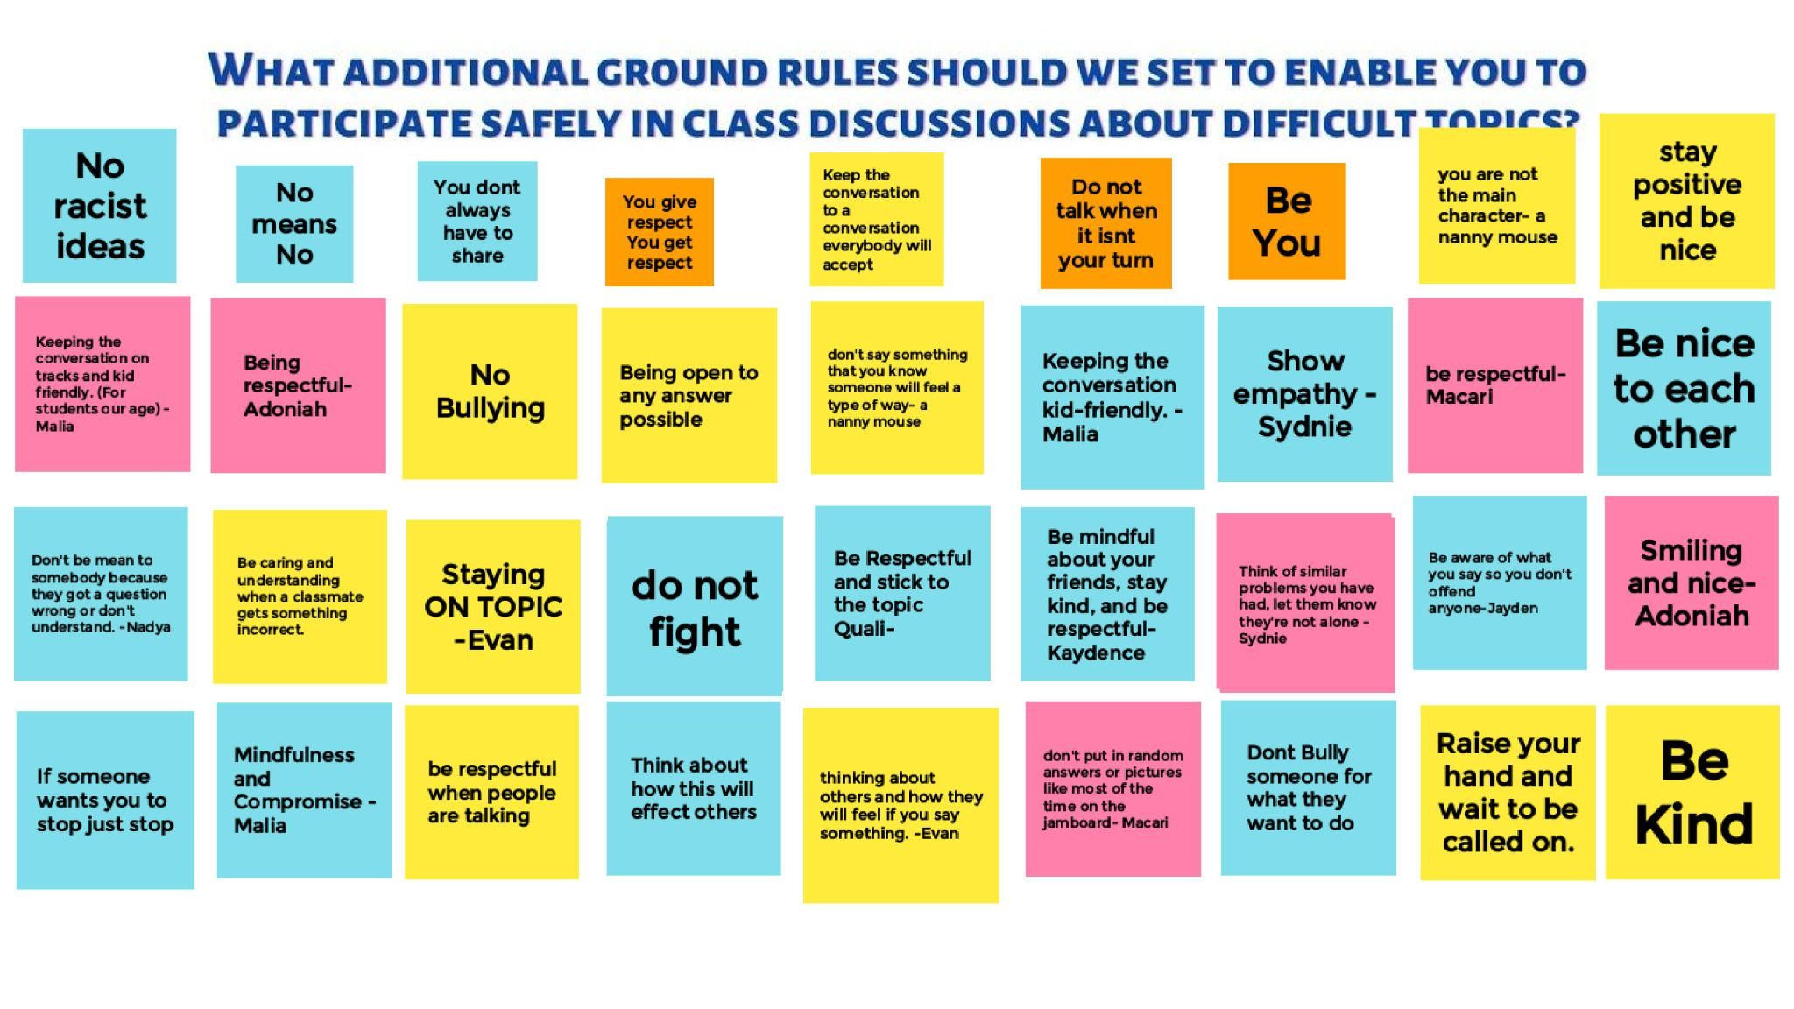
Example of student norms, Agboola, 5th grade.

Educator Note
For Hybrid or Remote Instruction: On a shared collaborative board (Jamboard is an option), students post answers to the question: What additional ground rules should we set to enable you to participate safely in class discussions about difficult topics?

For In-Person Instruction: On post-its students write down one or two answers to the question: What additional ground rules should we set to enable you to participate safely in class discussions about difficult topics?
Focus text(s) / resource(s) for today’s lesson
No Time To Complain: Art and Work Get This Student Through the Pandemic
This media is a video narrative illustrated and told through Derek, a high school student who is explaining the challenges of remote learning and life during covid-19. He explains articulately how art has provided him an outlet during this time. The overarching theme is how individuals can face challenges and improve others through storytelling.

Lesson / Activities
Exploring Key Terms | 25 mins
- Explain to students that when discussing hard or difficult topics it is important to have shared vocabulary. This allows for productive discussion because we understand we are talking from a shared understanding.
- Give students 10 minutes to add their thoughts or associated images to the following words:
  - Protest
  - Riot
  - Social Justice
  - Structural Racism
  - White Allies
  - Incite
  - Power
  - Bias
  - Privilege
  - Oppression
  - Diversity
  - Inclusion
  - Civic Action
  - Civic Engagement.
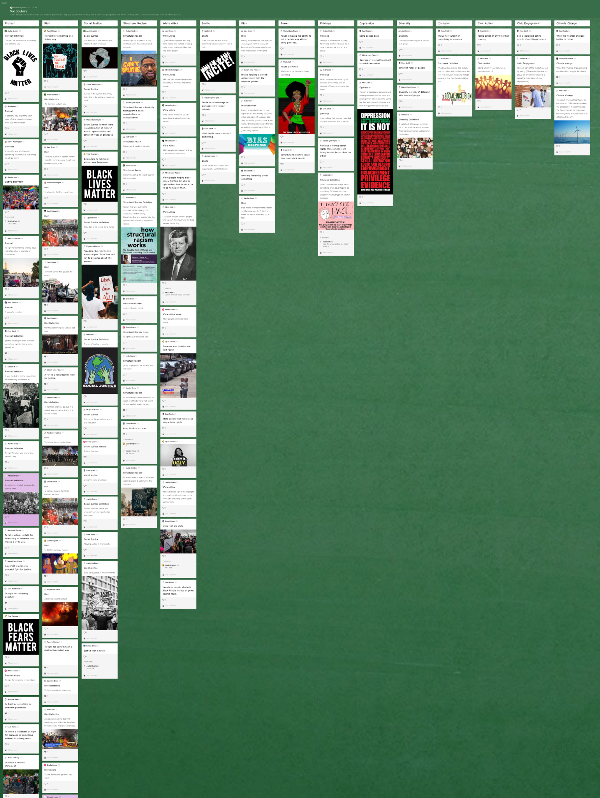
Example of student word gallery, Agboola, 5th grade

Educator note: This can be done on a Jamboard, Padlet or Gallery Walk for in person. If remote/hybrid, allow for students to add images to help them explain. Other accommodations can include pairs or group explanations, teacher provided cues (headlines, images, sentence starters) or voice inferences.

- Break students up into groups and assign each group two words to look up in a dictionary. Ask students to share dictionary definitions to the jamboard.
- Have students share or read other student responses for the words and discuss a shared definition from student inferences, researched definitions, and images.

Introduce the resource: “No Time to Complain: Art and Work Get This Student Through the Pandemic | 15 mins

- Introduce the video to students to provide them with background with an excerpt statement from the Pulitzer Center about the video:
Derek, 18, is a senior at City Arts & Tech High School and lives in a residential hotel in San Francisco’s Mission District. He works more than 25 hours a week at a local deli and is currently the sole breadwinner for his family. He talks about work and school during the pandemic and his dream for a future where he has the time and space to pursue his love for the creative arts.
- Play No Time To Complain: Art and Work Get This Student Through the Pandemic (3:45)
- After viewing, students respond to the following discussion questions:
  - What questions does the author raise for you?
  - What do you still have questions about?
  - What will be the most important thing to remember about what we read or viewed today?

Closing and Homework (if any)
- Ask a few students to share their responses to the discussion questions.
- Review the purpose of the lesson:
“You will create a print or non-print text product that highlights changes happening in their community during the pandemic. You must include one individual, organization or business. You may choose from a meme, video, Instagram style post, podcast, 3+ poems (written or spoken word), or info-graphic.”

Lesson 2
Protest
Lesson Objective(s) or Essential Question(s)
Students will be able to define protests as they appear through the span of 100 years.
Warm-up
- Refer to the definitions students added to the padlet for protest and riot.
- Ask students if there is anything they would like to add now.
Focus text(s) / resource(s) for today’s lesson
Thought Catcher: Warm Up

Garfield, L. (2020, June 01). 14 of the Biggest Marches and Protests in American History. Retrieved from https://www.businessinsider.com/largest-marches-us-history-2017-1

Dudenhoefer, N. (2020, July 02). 7 Influential Protests in American History, Serving as Acts of Patriotism. Retrieved from https://www.ucf.edu/news/7-influential-protests-in-american-history/
Lesson / Activities
The History of Protests in America
- Introduce the video “A Hundred Years of American Protest, Then and Now | The New Yorker”.
- Explain that students will watch this video twice. The first time is just to watch and the second time they will be answering two questions. Educator note: Tell students after the first viewing.
- Before the second viewing, introduce the individual thought catchers. Students will be recording their thoughts throughout the unit in this thought catcher.
- Students should answer the following guiding questions on their individual note catcher:
  - What do you notice?
  - What do you wonder?
- Provide time for students to share their wonderings. Record some on a whiteboard, large post it note, or digitally for other students to reference.

Reading News Articles
- Split students in small groups of 3 or 4. Explain they are now going to read through one the following articles:
- Garfield, L. (2020, June 01). 14 of the Biggest Marches and Protests in American History. Retrieved from https://www.businessinsider.com/largest-marches-us-history-2017-1
- Dudenhoefer, N. (2020, July 02). 7 Influential Protests in American History, Serving as Acts of Patriotism. Retrieved from https://www.ucf.edu/news/7-influential-protests-in-american-history/
- Students should record their responses on the note catcher section to the questions:
  - What questions do the authors raise for you?
  - What do you still have questions about?
Closing and Homework (if any)
- Ask one person from each group to share the following with the class:
  - A summary of the article
  - One question the author raised for the group
  - One detail about the article the group still has questions about
- Record these on the shared display for students' references. This will help them have resources for when they are creating projects.

Lesson 3
Equity in Education
Lesson Objective(s) or Essential Question(s)
Students will be able to...
- Identify issues of equity in education before the pandemic
- Form questions based on improvements
Warm-up
- Play the youtube video “Schools & Social Inequality: Crash Course Sociology #41”
- Students should answer the following questions in their thought catcher:
  - What do you notice?
  - What do you wonder?
Focus text(s) / resource(s) for today’s lesson
Unit Though Catcher

Life Is Unfair, but a Pandemic Rigs It Doubly Against Low-Income Student's
In this article students are exposed to two perspectives for remote learning. Through the author's interview, students can begin to understand how the pandemic exposed complications already in education. The deeper connection students can make is how learning environments may have changed but academic gaps were exasperated.

In Isolation, Abby Dreams of Space
This media, also art based, is the perspective of a student talking about learning during Covid-19 and how this impacts students and low income environments. Abby is able to illustrate her life before Covid-19 and during. Through this form of storytelling students are able to visualize and see how art can be a form of protest and storytelling.
Lesson / Activities
Exploring Reporting on Education Inequality
- Introduce the following videos by reading the accompanying passages:
- Life Is Unfair, but a Pandemic Rigs It Doubly Against Low-Income Students
- In Isolation, Abby Dreams of Space.
- Explain that students will read one article in a small group and discuss the following guiding questions:
  - What do you notice?
  - What do you wonder?
  - What would you share with someone who hasn’t read this?
- Students record responses on their thought catcher for the unit.
- Provide time for students to share their group discussions with the class. Record some on a whiteboard, large post it note, or digitally for other students to reference.
- Students will discuss these three questions in small groups after reading and listening:
  - What questions does the author raise for you?
  - What do you still have questions about?
  - How might this message connect to our theme of protest and civic engagement?
Closing and Homework (if any)
- Ask one person from each group to share the following with the class:
  - A summary of the article
  - One question the author raised for the group
  - One detail about the article the group still has questions about
- Record these on the shared display for students' references. This will help them have resources for when they are creating projects.

Lesson 4
Climate Justice
Lesson Objective(s) or Essential Question(s)
Students will be able to...
- Identify issues of equity in climate change before the pandemic
- Form questions based on improvements
Warm-up
- In small groups, students watch the following YouTube videos:
- “Greta Thunberg to world leaders: 'How dare you? You have stolen my dreams and my childhood”
- "A Message from the Future with Alexandria Ocasio-Cortez”
- "The Story of Bottled Water"

- Students should answer questions in their thought catchers:
  - What do you notice?
  - What do you wonder?
Focus text(s) / resource(s) for today’s lesson
NC Project Shows Opportunity in Resilience
NC Charts New Course on Climate Change
On the Largest Freshwater Island in the World, Lake Huron’s Native Americans Warn of the Fragility of Water

Unit Thought Catcher
Lesson / Activities
Exploring News Stories about Climate Change
- Introduce each of the following articles to students:
- NC Project Shows Opportunity in Resilience
- NC Charts New Course on Climate Change
- On the Largest Freshwater Island in the World, Lake Huron’s Native Americans Warn of the Fragility of Water
- Explain that students will read one article in a small group and discuss the guiding questions in their thought catchers:
  - What do you notice?
  - What do you wonder?
  - What would you share with someone who hasn’t read this?
- Provide time for students to share their wonderings. Record some on a whiteboard, large post it note, or digitally for other students to reference.
- Students should return to their groups and respond to these two questions after reading and listening:
  - What questions does the author raise for you?
  - What do you still have questions about?
  - How might this message connect to our theme of protest and civic engagement?
Closing and Homework (if any)
- Ask one person from each group to share the following with the class:
  - A summary of the article
  - One question the author raised for the group
  - One detail about the article the group still has questions about
- Record these on the shared display for students' references. This will help them have resources for when they are creating projects.

Lesson 5
Racial Justice
Lesson Objective(s) or Essential Question(s)
Students will be able to...
- Identify issues of equity surrounding racial justice before the pandemic
- Form questions based on improvements.
Warm-up
- Introduce The Legacy of Racial Injustice (2:11)
- In small groups, students watch the video and answer the following questions and record their responses in their thought catchers. :
  - What do you notice?
  - What do you wonder?
Focus text(s) / resource(s) for today’s lesson
Vaccinations in Black and White: Is It Hesitancy or Racial Bias?
Cielo’s Story: Empanadas and Life in the Pandemic
How COVID Accelerated a Fight Against Food Deserts

In these three articles students are able to see in one community how health care and food deserts were hit hard during the pandemic. When resources and healthcare were stretched then and communities that were already marginalized received less care, this led to further widening gaps in communities of color. Students can use this to further their understanding. Another aspect found in the last article, is how individuals and community organizations were helping during the pandemic to support their communities. The takeaway for students is that they can help amplify voices that were helping during the pandemic rather than solely focusing on the negative.

Unit Thought Catcher
Lesson / Activities
Exploring News Stories about Racial Justice
- Introduce each of the following articles to students:
- Vaccinations in Black and White: Is It Hesitancy or Racial Bias?
- Cielo’s Story: Empanadas and Life in the Pandemic
- How COVID Accelerated a Fight Against Food Deserts.
- Explain that students will read one article in a small group and discuss the guiding questions in their thought catchers:
  - What do you notice?
  - What do you wonder?
  - What would you share with someone who hasn’t read this?
- Provide time for students to share their wonderings. Record some on a whiteboard, large post it note, or digitally for other students to reference.
- Students should return to their groups and respond to these two questions after reading and listening:
  - What questions does the author raise for you?
  - What do you still have questions about?
  - How might this message connect to our theme of protest and civic engagement?

Closing and Homework (if any)
- Ask one person from each group to share the following with the class:
  - A summary of the article
  - One question the author raised for the group
  - One detail about the article the group still has questions about
- Record these on the shared display for students' references. This will help them have resources for when they are creating projects.

Lesson 6
The Performance Task
Lesson Objective(s) or Essential Question(s)
Students will be able to…
- Select their topic and project medium for their reporting
- Research stories in their neighborhood
Warm-up
Have students share what stories stood out for them during the last five lessons.
Focus text(s) / resource(s) for today’s lesson
Art & Journalism: A Marriage of Mediums

Performance Task and Rubric Worksheet

Lesson / Activities
Students as Journalists
- Introduce the article “Art & Journalism: A Marriage of Mediums.”
- Students review the following quotes from the article and share what they think the journalist means with each quote.
  - Dawes: "I felt a lot of gratitude for their willingness to tell me their stories and to tell me about their lives...and that is important to me as a human being and, above all else, as an artist"
  - Lambertson: "window into someone's life," providing individuals with an opportunity to learn from and listen to the people—an integral component of journalism, for journalists and audiences alike.
  - France: There are ways that you can convey in more pure art forms—like film—emotional truths that are more profound or at least more profoundly perceived than what you can do with print
  - Finneran: The emotional openness [associated with art] is what allows people to be open to changing their opinion or open to engaging deeper in an issue, and that is what leads to change.
- Explain to students that they will be journalists and share stories from our community of healing and making things “better than normal”.

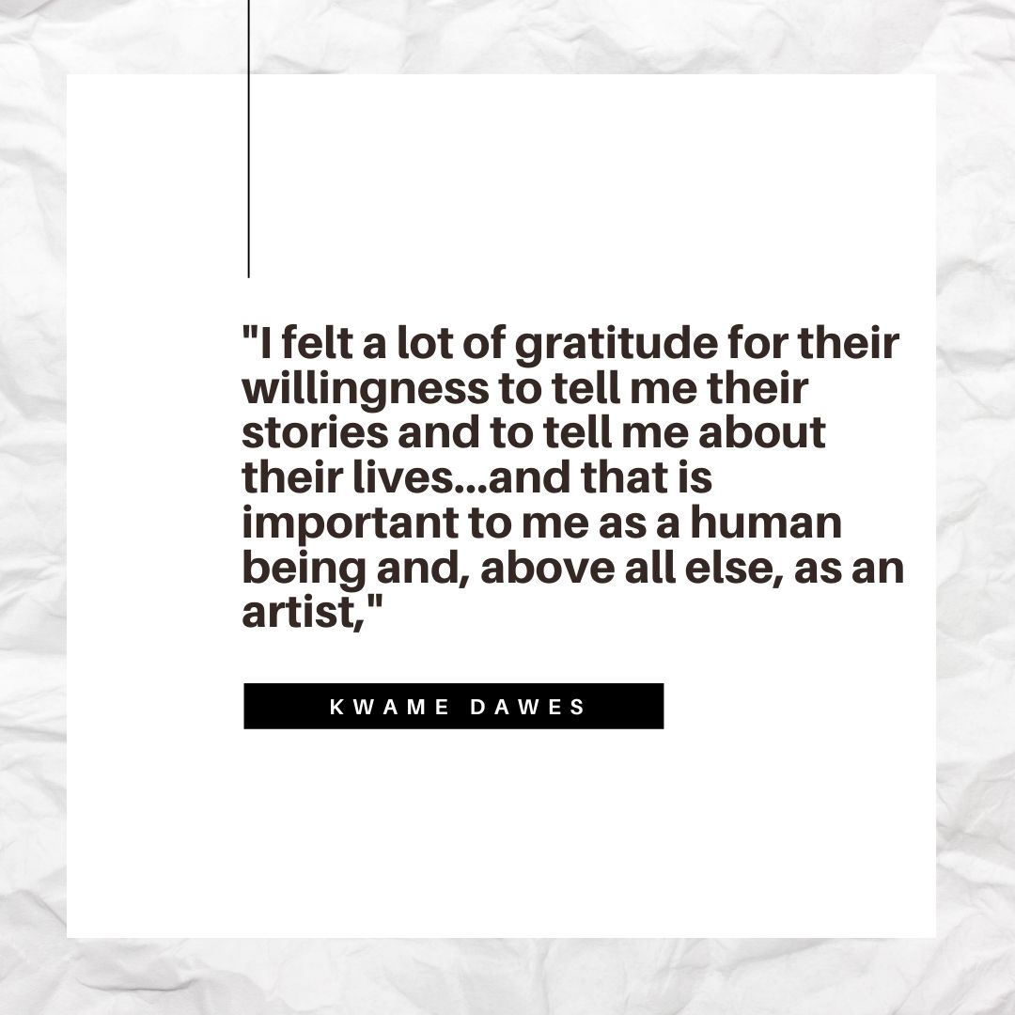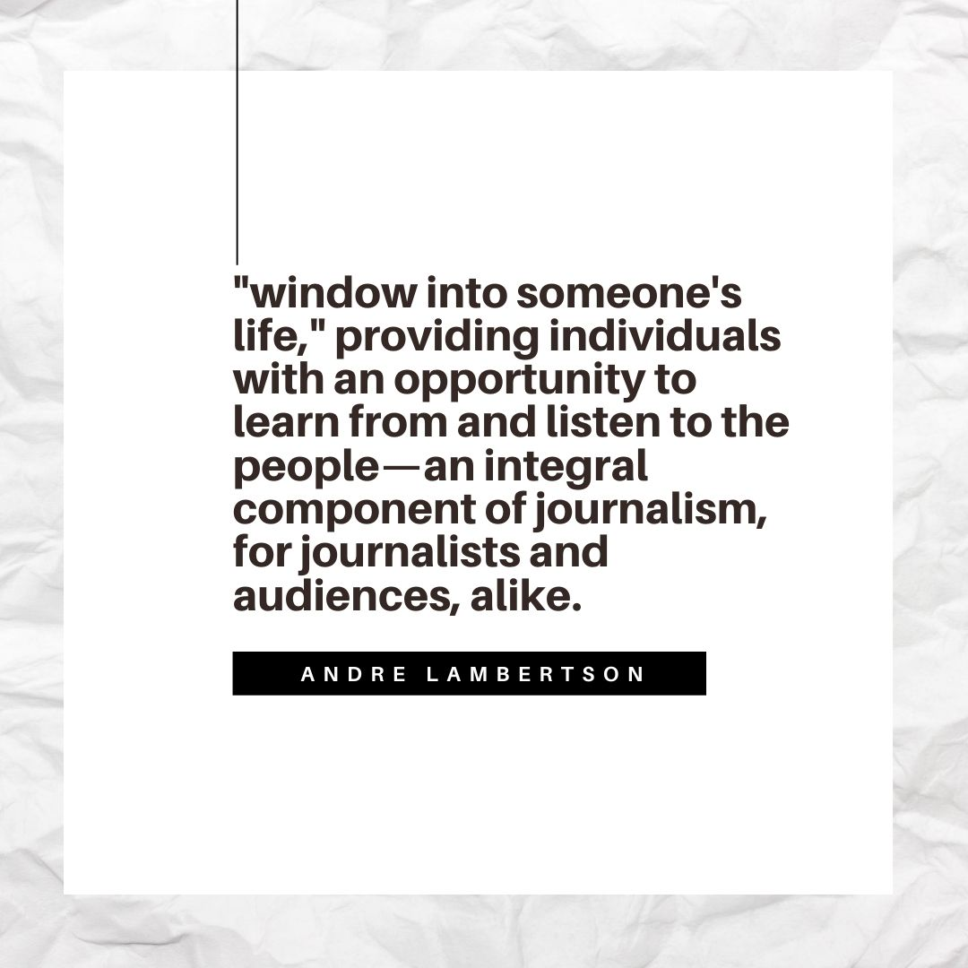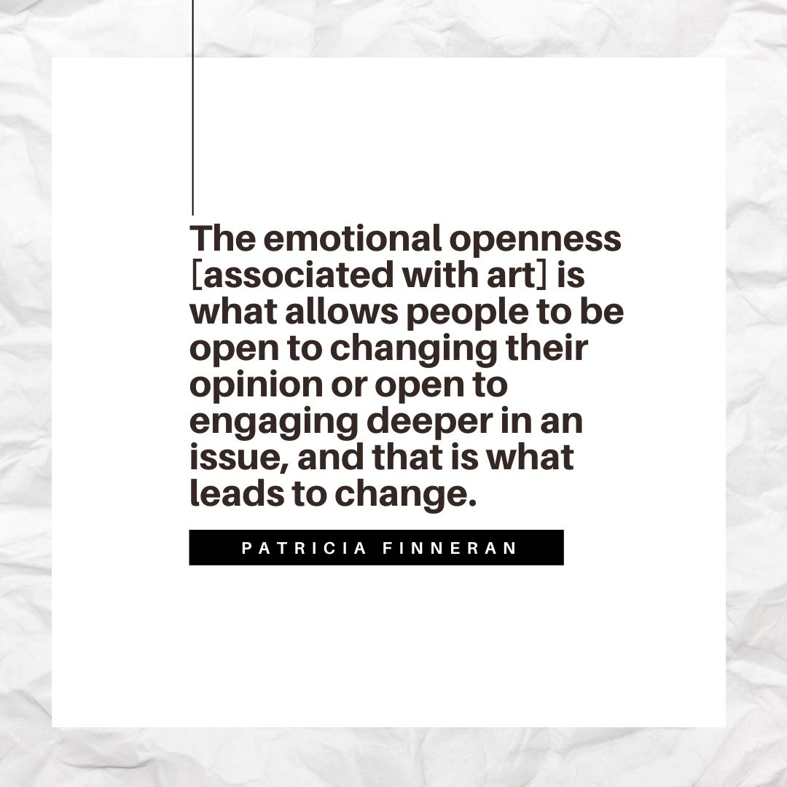
Quotes pulled from “Art & Journalism: A Marriage of Mediums,” written by Katherine Ruzzo, the Pulitzer Center

Introduce the Performance Task
- Ask students to consider the three themes we explored: education, racial equity, and climate change.
- Introduce the performance task to students. Tell students that they will create a print or non-print text product that highlights changes happening in their community during the pandemic. They’ll find at least one individual, organization, or business in their community that has made positive changes. Examples of positive change might be ________.
- Students may choose from any of the following product options:
- Infographic
- Video
- Podcast
- 3+ poems (written or spoken word)
- Photojournalism
- Memes
- Share the following questions to guide their research and creation:
  - In this topic, what were issues of inequity before the pandemic in our community?
  - During the pandemic, how did this issue worsened?
  - What opportunities of change does the pandemic present?
  - What messages of hope from the community should be amplified about changes in the community?
  - Who are making these changes?
  - What are the changes? Why are these changes important?

Closing and Homework (if any)
Students should be ready to present in 1-2 weeks and have check-ins with the teacher in between that time.

