Listening to Immigrants’ Stories:
Comparing the American Dream to the Reality Upon Arrival to the United States
By Vanessa Carcanaquez

Lesson 1
Lesson Objectives & Essential Question
Students will be able to...
- Define journalism, ethics, slander, libel and bias.
- Describe the process of journalistic writing.

Essential question:
How is journalism an effective tool to provide insight into current social issues?
Warm-up
What is journalism?
- To gain insight about their background knowledge regarding journalism, students will answer the following questions on a jamboard slide:
  - What is journalism
  - What comes to mind when you think of the word “journalist?”
- Students will review and discuss each others’ responses.
- As a class, students will agree to a broad definition of journalism.
Focus text(s) / resource(s) for today’s lesson
Google Slides Notes [PDF]
Jamboard (will prompt you to make a copy)
The Paradise Papers: A Lesson in Investigative Journalism Objective: Warm-up: (to be used if journalist visit is not possible)
Lesson / Activities
Learning Journalism Terms
Students will actively participate in the notes using Google Slides and Peardeck. Students will learn the basic terminology of journalism (beat, 5W-H, headline, lede [lead], byline, news, inverted pyramid, quotation, interview, slander, libel, reporter, ethics) . They will understand the ways in which journalism impacts the information that is reported. Students will understand the way the media impacts the stories that are reported and under-reported stories.

Interviewing a journalist
Students will then interview a journalist that is visiting class. Students will be able to ask questions regarding the daily tasks of a journalist and the process of writing an article. Possible questions for the journalist (adapted from the attached lesson):
- How would you describe the day-to-day work of an investigative journalist?
- What are your workplaces like?
- Did anything surprise you about becoming a journalist?
- What skills do you think are essential for an investigative journalist to have, and why?
- What are some of the dangers of investigative journalism, and how do journalists cope with them?

***If a visit with a journalist is not possible, this lesson can be used to give students a deeper understanding of what the day-to-day looks like for a journalist.

Closing
Students will discuss what they look forward to in being journalists on slide 2 of the Jamboard.

Lesson 2
Lesson Objectives & Essential Question
Students will be able to...
- Understand the significance of immigrants in United States history
- Identify the variety of reasons for immigrating to the United States

Essential Question:
Why are immigrant stories significant in United States history?
Warm-up
Migration Photo Walk
- Students will review images of various migration scenarios on a Jamboard.
- Students will share their reflections about the images on the Notice, Think, Wonder Notecatcher.
Journalism Vocabulary
- Students will use the google slides presentation to learn the following terms associated with immigration and immigration stories:
  - Beat
  - 5 W’s and H
  - Headline
  - Lead
  - News
  - By-line
  - Inverted Pyramid
  - Quotation
  - Interview
  - Slander
- As a whole group, the teacher will present each image depicting various individuals in their journey of migration. After each image is shown, students will have two minutes to write all the things they notice in their Google Slide. Once the two minutes have passed, ask for at least three volunteers to share what they noticed.
- The teacher should then ask the students what they think is happening in the photo, what they think the circumstances might be, and write for another two minutes in the “Think” column of the Google Slide. Finally, students can be asked to write about anything they are still wondering about. Allow time for students to discuss with one another.
- Once all images have been discussed, show students the link to each source of the image with the article headline. Depending on time, the teacher can quickly present the articles on the screen to give students a glimpse into the context regarding the images discussed.

In small groups, students will brainstorm a list of reasons that people may immigrate to the United States (on the Jamboard).

List of sources for images:

Image 1: Refugees From the Earth

Image 2: Refugees in Colombia

Image 3: In Honduras and Vietnam, Women Migrate To Secure a Better Future

Image 4: How U.S. Immigration Policy Affects Fate of Migrants Braving the Deadly Darien Gap

Image 5: Undocumented in the Pandemic: 'Nowhere Else to Go'

Image 6: Where the Bodies Aren't Buried

Image 7: The Moving Border: Part One, the North

Focus text(s) / resource(s) for today’s lesson
Migration Journey Photo Walk Jamboard
Notice, Think, Wonder Notecatcher
The Value of Listening to Others Google Notes [PDF]
Lesson / Activities
- Teacher will present slides 8-9 of the slideshow to provide background information.

What motivates migration?
- In small groups, students will brainstorm a list of reasons that people may immigrate to the United States.
- Students share their list out with the class.

Lesson 3
“Coming to America”
Lesson Objectives
Students will read and annotate the article “Coming to America” in order to understand the unexpected hardships faced by immigrants when arriving in the United States.

Students will be able to:
- Read and annotate the article “Coming to America.”
- Summarize the sections of the article “Coming to America”
- Describe the challenges faced by immigrants arriving to the United States
Warm-up
- Introduce the article by Francesca Bentley “Coming to America: It’s Not Like the Movie”
- Students will preview the title and images in the article.
- Students will respond to the following questions:
  - What do you think this article will be about?
  - Why do you think people who do not live in the United States have an image of America that makes it seem ideal?
  - What do you think would be a shocking discovery if you came to the United States for the first time?
Focus text(s) / resource(s) for today’s lesson
“Coming to America: It's Not Like the Movie”

Padlet Example

Coming to America: It's Not Like the Movie Summarization
Lesson / Activities
- Share the following annotation guide with students:

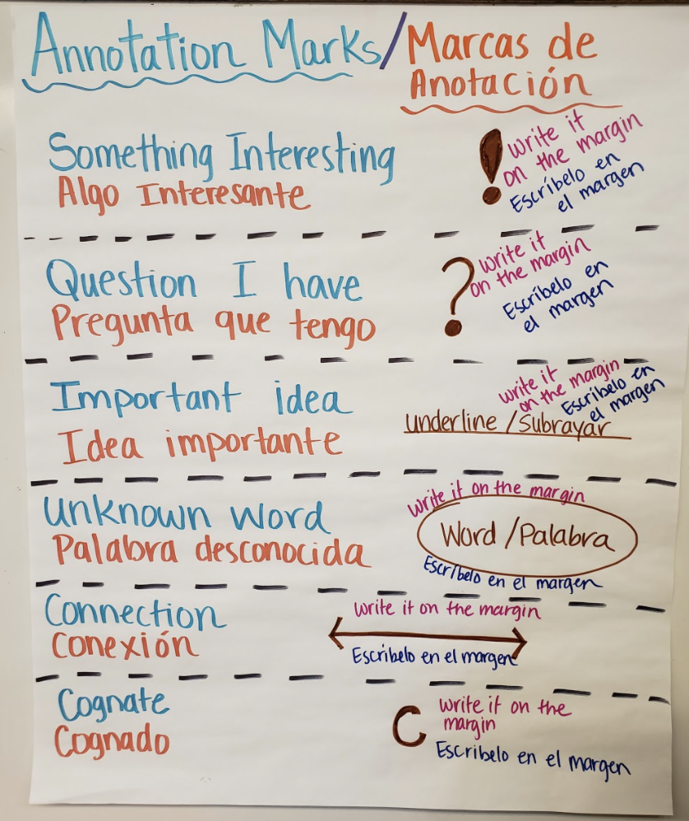

- Students can read and annotate the article independently, in small groups, or as a whole class.
- Teacher will then review the definition of the 5W and H (Who, What, Where, When, Why, and How) and explain the significance of summarizing. Summarizing allows students to explain the most important information in each section of an article. Students will then complete the 5W and H Google Slides document independently.
- Students will use the summarization graphic organizer to outline the most important information from each section of “Coming to America.”
Closing
Students should finish summarizing “Coming to America.”

Lesson 4
Becoming an investigative journalist project introduction
Lesson Objectives
Students will be able to...
- Identify the qualities of a journalism project.
- Understand the expectations for the final performance assessment.
Warm-up
- Reshare the day 1 jamboard and ask students to revisit what it means to be a journalist.
- Ask students to add additional thoughts to the jamboard or share out loud additional insights.
Focus text(s) / resource(s) for today’s lesson
The Value of Listening to Others Google Notes
Project Description and Rubric
How Promotoras de Salud Are Fighting Vaccine Conspiracies in Chicago’s Latino Communities
How Promotoras De Salud Are Fighting Vaccine Conspiracies In Chicago’s Latino Communities Audio
Lesson / Activities
Review Performance Task
- Share and review the project description and rubric with students.

Analyze Audio Clips
- Students listen to Promotoras de Salud Audio to understand how a narrative audio presentation should sound. Sample is linked here.
- Students will analyze the qualities of the narrative audio by answering the following questions:
- What did you notice about the storytelling?
- What type of information did the interviewer include?
- Why is it important to include voice over narration to tell the story?

Closing and Homework
- Ask students to review rubric and make a list of clarifying questions.
- Students should schedule interviews to take place within the next week.
  - Remind students that as a journalist, they should call their interviewee and request the interview.
  - The interviewer (journalist) should work around the schedule of the interviewee and be sure to schedule 30 minutes to complete the interview.

Lessons 5 and 6
The Moving Border: Part One, the North
Lesson Objectives
Students will be able to:
- listen to an audio news story and analyze the significance of immigration policy
Warm-up
Ask students to share what they know about “the wall” along the US/Mexico border.
- What comes to mind when you think of the wall?
- What misconceptions are associated with the wall?
- What misconceptions do you think Americans have about people trying to cross the border?
- What message do you think the wall sends to migrants about the United States?
Focus text(s) / resource(s) for today’s lesson
The Moving Border: Part One, the North

Example of student work on Jamboard: Example 1, Example 2, Example 3, Example 4
Lesson / Activities
Exploring “The Moving Border”
- Introduce Maria Hinojosa’s “The Moving Border,” published in Latino USA.
- Students read the brief accompanying text on the project page in small groups and share a summary of the text with the class.
- Students will add a sticky note on the Jamboard with their name and answer the following questions:
  - How do you think immigration policy affects asylum seekers?
  - What are some of the dangers that asylum seekers face when immigrating towards the United States?

- After listening and discussing the dangers faced by asylum seekers, the students’ focus should shift to the technical aspect of the audio project. On slide 2 of the Jamboard, ask:
  - From a technical/ formatting perspective: What were some of the techniques the journalist uses to tell the story while keeping the interview to be the main focus?
Closing
Ask students to journal about the following question:
- How does government policy negatively impact marginalized individuals?

Lesson 7
Intimate Images of One of the Largest Refugee Populations in the World
Lesson Objectives
Students will be able to:
- Use images to analyze the difficulties faced by refugee populations
Warm-up
Ask students to define the term “refugee” on a collaborative board (padlet, jamboard, whiteboard, or whole group discussion)
Focus text(s) / resource(s) for today’s lesson
“Intimate Images of One of the Largest Refugee Populations in the World” by Sarah Hylton, Vice News

Intimate Images of One of the Largest Refugee Populations in the World Jamboard
Lesson / Activities
- Introduce Sarah Hylton’s ““Intimate Images of One of the Largest Refugee Populations in the World” published by Vice News.
- Students will read the text accompanying the images in the article.
- Ask students: What are some reasons you think refugees are fleeing from their home countries (countries of origin?)
- BEFORE reading: On the Jamboard, students will discuss:
  - What are things you know/ have heard about Pakistan or the Middle East in general?
- AFTER reading: On Slide 2 of the Jamboard, students will reflect:
  - What do you think it would be like to grow up in another country where your culture is not accepted and you are not allowed to attend school or own property?
Closing
Lead a whole group discussion on the recurring idea that people emigrate for a variety of reasons from around the world:
- What are you noticing about the reasons that people emigrate to the United States from around the world? What are some common themes that fuel the journey?
- What are some of the challenges that immigrants, migrants, and refugees face when leaving home?

Lesson 8
Writing Interview Questions//Importance of Personal Stories in history
Lesson Objectives
Students will be able to:
- Write interview questions.
- Understand the importance of individual stories in understanding global issues.
Warm-up
Students will contribute at least two responses to the following question on a jamboard:
If you were going to interview me (your teacher) what types of questions would you ask?
Focus text(s) / resource(s) for today’s lesson
The Value of Listening to Others Slide Note [PDF]

“El nuevo suroeste de Chicago: joven, latinx, y listo para liderar” – Lynda Lopez, South Side Weekly

5W-H Graphic Organizer

Interview Script

Spanish Copy of Interview Script

Lesson / Activities
Read and Annotate Article about Latinx communities in Chicago
- Introduce El nuevo suroeste de Chicago: joven, latinx, y listo para liderar – South Side Weekly (English text is linked in this article) to students.
- Have students read and annotate the article, making personal connections to the text.
- Students will complete the 5W-H graphic organizer independently.
- Students will be divided into small groups to come up with five “non-negotiable” questions that should be included in the interviews. Student samples here: Sample 1, Sample 2, Sample 3, Sample 4
- As a whole group, decide what questions from the suggested questions should be asked.
- Teacher can then edit the interview script to adjust any questions that students might have added.

Closing and Homework
Preparing for Interview
- Students should choose a person to interview.
- Students should ask their permission to be recorded for an interview project. They can provide their interviewee with this permission form.

Permission form here.

Lessons 9-10
Recording interview- media lesson/ refugees
Lesson Objectives
Students will be able to
- Practice using audio recordings to record interviews/
- Understand the sensitive nature of asking someone about their personal experience.
Warm-up
Ask students to complete a survey about their comfort with audio recording. Survey can be done on a jamboard or google slide.
Focus text(s) / resource(s) for today’s lesson
The Forgotten OneƵ
Audio Recording Guide
Narration (voiceover) Planning Doc
Survey
Lesson / Activities
Practice Audio Recording
- Review the document with various audio recording options with students.
- Break students up into small groups and give them time to practice one recording option.

Read The Forgotten OneZ
- Introduce The Forgotten OneƵ by Angèlica Ekeke
- Break students into small groups and ask them to read and annotate the article.
- Using a jamboard, students can respond to the following questions:
  - What dream fuels the journey that immigrants, migrants, or refugees take when they leave their country of origin?
  - What realities do they face when they leave their homes?
  - What feelings might immigrants, migrants, or refugees experience when they arrive in a new country?
  - What distinction can you make about the dream vs. the reality that immigrants face when they leave home?
- Students will plan their voiceover narration on this document to have prepared narration when they are editing their audio projects.

Homework
Students should complete their interviews and upload their audio to the assignment on Google Classroom. If the file is too large, the file can be shared via Google Drive directly.

Lesson 11-12
Presentations of audio projects
Lesson Objectives
Students will be able to
- Listen to a small group of students’ presentations
- Provide feedback on the technical aspects of the audio project using the rubric
Warm-up
Review the rubric for the project with students. Hold space for questions.
Focus text(s) / resource(s) for today’s lesson
Rubric

Lesson / Activities
Student Work Day
Students should have the audio from their interview uploaded and shared with the teacher.

Students will need to have completed the interview and will work independently to plan their voiceover narration on this document.

Educator note: I gave my students 2 class days to work on this project. I would recommend setting at least 2 to 4 days for students to craft their audio projects. It was most beneficial when other students in the Google Meet shared their screens and walked through their process of editing the projects. Likewise, if a student was having difficulties with the editing, they can share their screen in a Google Meet and have their peers and teacher offer support and guidance.

Audio Presentations
Invite students to share their audio presentation in small groups (or whole group depending on time and class size) .Students will use the rubric to grade and provide feedback on the technical aspect of the interview.

