Video
Title: Catholics, Coffee and Climate Change

Teaser: This video examines how small coffee farmers in Colombia are fighting against the impact of climate change with the assistance of the catholic church and what is in store in the future.
Summary:: Experts say in 30 years nearly half of the land in Nariño, Colombia will not be able to produce coffee, which will leave over 40,000 families unemployed. The Catholic Relief Services works with 1600 families in Nariño struggling with the impact of climate change and experimenting with new techniques of how small coffee production can survive with the severe climate changes.

Photo: 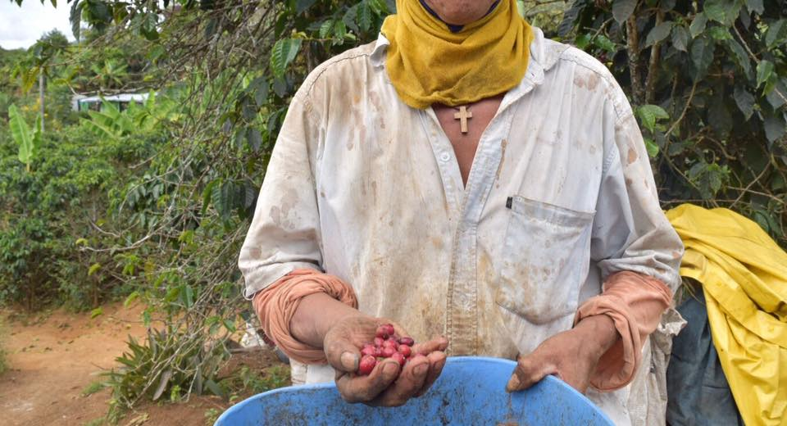

Caption: With a wooden cross necklace clasped around his neck, a rural farmer look down at his hand full of coffee beans praying that conditions will get better.

