Comparing and Contrasting Global Migration Policies
Unit by Dr. Matthew Wynne

Lesson One

Lesson Objective
Objective: I can define migration

Warm-up
Students examine a political cartoon related to migration in the U.S., such as the one below, and discuss.
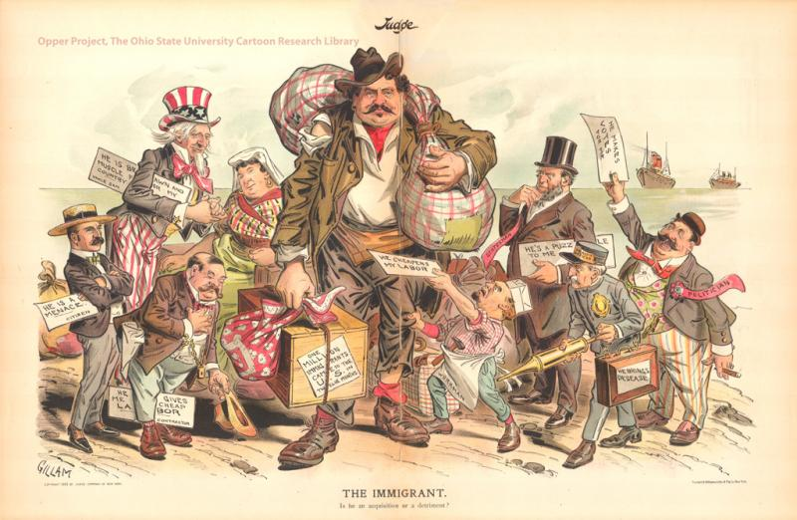

1. Students list any words, people, or items they observe in this political cartoon.

2. Students describe the action taking place in this political cartoon.

3. Students evaluate how this political cartoon relates to migration in the USA.

Focus text(s) / resource(s) for today’s lesson
Texts:
“The Moving Border: Part One, the North” by Maria Hinojosa for NPR’s Latino USA
“The Coronavirus Pipeline” by Anna-Catherine Brigida and Morena Perez for The Texas Observer

Worksheet:
- KWL Chart [.pdf]
- KWL Chart [.docx]

Lesson / Activities
1. Students will define the following terms: migration, immigration, and refuge.

2. Share directions for a gallery walk with students. The instructor may have students walk individually in a line or in groups to observe the images hanging throughout the classroom. (Virtual: Students may be sent the images individually in a file.) Here are example images that could be explored in a gallery walk.

3. Students will view each image and answer the following analysis question based on their observation from the gallery walk of images.

- What story does this image tell about migration/migrants? Explain using evidence / observations from the image.

5. Students will then return to their seats and the instructor will call on students to relay their impressions from the images. Then, discuss as a class:

- What stories, and whose stories, did you see represented in these images?
- What stories, and whose stories, do you think might be missing from these images?

6. With any remaining class time, students should begin their homework assignment for the week (see below).

Closing and Homework (if any)
Students can choose between the following two news stories:

- “The Moving Border: Part One, the North” by Maria Hinojosa for NPR’s Latino USA
- “The Coronavirus Pipeline” by Anna-Catherine Brigida and Morena Perez for The Texas Observer

They should listen to / read their chosen story and note specific examples of how policy impacts the lives of migrants.

For homework, students complete this KWL Chart in order to reflect on U.S. migration policy. This will bridge into the next lesson how policy affects migrants and migration around the world.

Lesson Two

Lesson Objectives
Objectives:

- I can understand how migration impacts diverse nations
- I can analyze issues and trends of migration through news articles

Warm-up
Ask students to refer to their KWL Charts. Discuss as a class:

- What is one thing you learned from exploring your chosen news story?
- What are some of the questions you have about how policy impacts migrants’ lives?

Focus text(s) / resource(s) for today’s lesson
Introductory video: "What Are Underreported Stories?" by the Pulitzer Center

Worksheet:

- Pictorial journal [.pdf]
- Pictorial journal [.docx]

Texts (students will work in small groups, and will choose one article offered for their chosen / assigned region):

Africa:
- “Desert or Sea: Virus Traps Migrants in Mid-Route Danger Zone” by Lori Hinnant and Isabel Debre for the Associated Press
- “Between the Desert and the Sea: The Plight of Refugees in Morocco” by Megan Pierce for the Pulitzer Center

Middle East
- “African Migrants Reel as Israeli Law Cuts into Salaries” by Caron Creighton for the Associated Press
- “Across Oceans: The Lives of Migrant Workers in the Middle East” by Svanika Balasubramanian for the Pulitzer Center

South America
- “A Country that Welcomes Migration” by Patrick Ammerman and Gustavo Andrés Castillo Arenas for YES! Magazine
- “No Country to Call Home? Some Babies Born in Colombia to Venezuelan Parents Lack Birthright Citizenship” by Megan Janetsky for USA Today

Oceania
- “Why New Zealand Is Furious About Australia’s Deportations Policy” by Sylvia Varnham O’Regan for The New York Times

Lesson / Activities
1. Let students know that they will be transitioning from exploring how policy impacts migrants’ lives in the U.S. to exploring and comparing how policy affects migrants’ lives around the world. Ask students: What have you heard about migration outside of the U.S.?

2. Note that migration outside of the U.S. is often an underreported story. Screen this video (3:26) to guide students in understanding what underreported stories are.

3. Students will be divided up into groups and will investigate immigration and migration policies in Africa, the Middle East, South America, and Oceania.

3. In their group, students will read one of the articles provided (see focus text(s) / resources for today’s lesson above).

4. In their group, students answer the following questions:

- What did you learn about migration policy in your group’s region from the article you explored?
- What did you learn about how migration policies affect people’s lives in your group’s region?
- Do you agree or disagree with these policies? Explain why,
- How would you maintain or make changes to these policies regarding immigration and migration in the region you explored?

5. Groups share their answers with the class, then discuss:

- How are the policies you learned about today (in your group, and from other groups who shared) similar to U.S. policies you are aware of? How are they different?
- From what you’ve read so far and from what your classmates have shared, how might you compare and contrast migrants’ experiences in different regions?

6. With any remaining class time, students should begin their homework assignment for the week (see below).

Closing and Homework (if any)
Students use this worksheet to draw or find an image that represents the experience of migrants in the region they read about in the Pulitzer Center news article. Then, they write a short first-person “journal entry” from the perspective of a person migrating to that region.
Lesson Three

Lesson Objective
Objective: I can evaluate the fairness and equity of migration policies in diverse nations

Warm-up
Ask students to return to their KWL Charts. Now that they have all explored at least one additional article focusing on a different region of the world, discuss as a class:

- What could you add to the L column? In other words, what new information have you learned about how policies affect migrants’ lives?
- What could you add to the W column? In other words, what questions do you still have?

Focus text(s) / resource(s) for today’s lesson
Texts: U.S. and global migration policy articles from previous class periods

Handout:

- Final project instructions [.pdf]
- Final project instructions [.docx]

Lesson / Activities
1. Introduce students to the final project instructions. Give them time to read independently, ask questions, and ultimately choose one of the four options. Let students know that, whichever option they choose, their project should focus on all of the following:

- Migration policy
- How policies affect migrants
- Citing factual information from at least two of the news stories assigned in this unit

2. Students will work in groups, pairs, or individually to complete the following for their social justice action project.

Closing and Homework (if any)
Students will finish their projects.

Optional fourth lesson: Students share their projects in a culminating celebration. Students evaluate and celebrate one another’s work using a peer evaluation worksheet. Finally, students complete a reflection on the unit and evaluate their own learning.

