The Paradise Papers: A Lesson in Investigative Journalism
Objective:
You will be able to…
- Describe the process, identify the purpose, and evaluate the impact of investigative journalism
- Evaluate the use of different types of media in achieving particular aims
- Create a resource that clearly and engagingly conveys information about the Paradise Papers

Warm-up:
1. BREAKING NEWS! There has been a tip — a piece of news about your school, neighborhood, or community that someone powerful doesn’t want you to know. Your source has chosen to remain anonymous, meaning you don’t know who they are. Your source’s information might be true or untrue.
The recycling at the biggest company in your town does not actually get recycled at all; instead, the company sends it off to the landfill while claiming state tax benefits on the recycling equipment and process costs they don’t, in reality, have.
2. Brainstorm on your own:
- What steps could you take to determine whether this information is true and what the fuller story behind it is?

- What would be the benefits and drawbacks of keeping this information secret while you investigated it further?

- If you shared this information, who would be affected and how?

3. What advantages and disadvantages can you see to working with a partner on your investigation?

Background:
UNESCO defines investigative journalism as “the unveiling of matters that are concealed either deliberately by someone in a position of power, or accidentally, behind a chaotic mass of facts and circumstances - and the analysis and exposure of all relevant facts to the public.”
Investigative reporting projects can begin in many ways. Sometimes, a journalist notices a problem or something suspicious themselves and decides to research it some more. Other times, they receive a tip from a source and work to determine whether it is true and what the full story is. In still other cases, a source might provide a leak (send secret information), supplying all the necessary documentation, but requiring the journalist to piece together a narrative from the information and find a way to present it to the public.
Reflect:
- Are you familiar with any investigative journalism stories?
- What do you think is the difference between investigative journalism and other types of journalism?
Today, we are going to learn more about investigative journalists and their work by examining the Paradise Papers, a project from the International Consortium of Investigative Journalists (ICIJ). This project exposes how political leaders, businesspeople, and the wealthy elite around the world use offshore entities to avoid taxes and cover up wrongdoing. With about 400 journalists working on 6 continents and in 30 languages to examine 13.4 million files for nearly an entire year, it is one of the largest investigative journalism projects in history.
Following this lesson, you will create a resource to clearly and engagingly convey information you have learned from the Paradise Papers to a lay audience, a vital part of investigative journalism.

Introducing the Reporting:

Resource 1: “The True Story Behind the Secret Nine-Month Paradise Papers Investigation”
Watch the video, and write down your answers to the following questions on a separate sheet of paper.
- After watching the video, create a short summary of what the Paradise Papers are and why they matter.
- In the video, ICIJ Deputy Director Marina Walker says, “At ICIJ, the mission is to uncover those urgent stories of public interest that go beyond what any particular journalist or media organization can accomplish on his or her own.” Consider:
  - What is the ICIJ? How does it differ from other news outlets/organizations you are familiar with?
  - How would you define a “story of public interest”?
  - Why does the ICIJ work with journalists based all over the world?
- This video introduces many reporters and shows them doing the behind-the-scenes work of investigative journalism. Discuss as a class:
  - How would you describe the day-to-day work of an investigative journalist, based on what the video showed? What are their workplaces like? Did anything surprise you?
  - What skills do you think are essential for an investigative journalist to have, and why?
  - How does the job differ for journalists in different countries?
  - What are some of the dangers of investigative journalism, and how do journalists cope with them?
  - Investigative journalist Will Fitzgibbon mentions ICIJ’s emphasis on releasing all information simultaneously as a team. What are some of the advantages and disadvantages to reporting this way?

Resource 2: “Paradise Papers”
Read the project description of the Paradise Papers on the Pulitzer Center website. How do the summary and statement of import you wrote compare? Write down your answer in the space provided.

Next, explore the interactive within the project, “Paradise Papers: The Influencers.” Write down your answers to the following questions on a separate sheet of paper.

- What is your initial reaction to the interactive? How does it make you feel?
- Click through to read the stories about Wilbur Ross. What sections are included in the story, and what purpose do they serve? Do you find the information convincing? Easy to understand? Interesting?
- Take a look at one of the supporting documents. What is your initial reaction? How does it make you feel?
- What do you think the purpose of this interactive is? How effective is it in serving this purpose?

Activity:
Summarize each of the political cartoons below in your own words:

1.

2.

3.
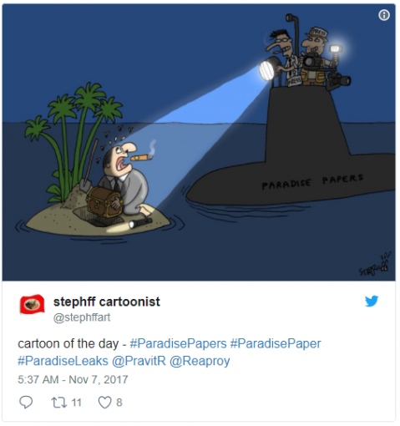
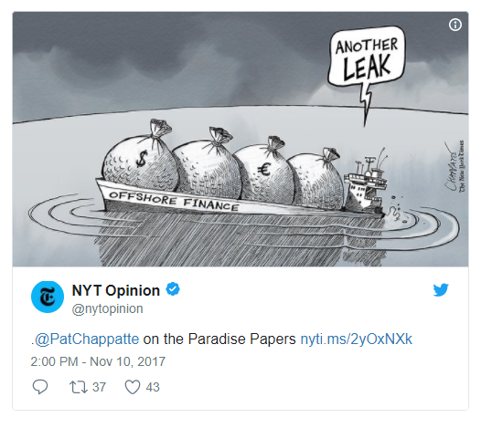

It's unlikely that any private citizen is going to sit down and read 13.4 million files, no matter how significant their value. As such, it is the job of the investigative reporters involved to mine that data for digestible, engaging stories that the public needs and wants to hear.

Explore the Paradise Papers investigation on the Pulitzer Center and ICIJ websites. Make a list of the different ways the ICIJ has found to tell this story.

- For each item on your list, who do you think the target audience is?
- What do you think are the most effective ways in which the stories of the Paradise Papers have been told thus far?
- Can you identify any audience(s) these stories are unlikely to reach as a result of the ways it is currently being told?
- What additional ways would it be possible to tell these stories?
- What impacts have the Paradise Papers had already, and what further impact can you foresee?
- Each group should share their main takeaway(s) from their conversation with the class.

Extension Activity:
1. Building on your final discussion, identify a target audience that you think should know about the Paradise Papers investigation. Create a resource that summarizes the following in a way that will resonate with your target audience:

- What are the Paradise Papers?
- Why are they important?
- How did journalists investigate the story?
- You can create a video, infographic, lesson plan, or any other resource. You may alternatively plan a large-scale resource (for example, a museum installation or a play) that you describe in detail but do not execute.

2. Present your resource to the class. Following your presentation, discuss the strengths, weaknesses, and possible impact of such a resource.

