Contagion in New York City: 1832
November 10, 2014 | Discourse in Progress
BY SONIA SHAH

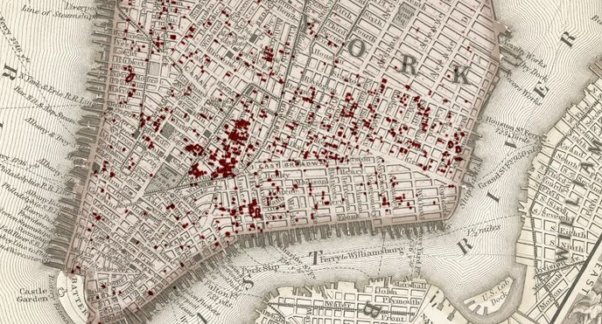
The contagion that hit New York City the summer of 1832 was as frightening, deadly, and as poorly understood as Ebola is today: cholera.
The disease, which originated in South Asia and had recently exploded in Paris, London, and Montreal, had never been seen in the United States. But New Yorkers had heard the news: Cholera ruthlessly killed about half of its victims, draining their bodies of fluids in a matter of hours through massive expulsions of vomit and diarrhea. Nobody knew how it spread or how to cure it.
Today we know that cholera spreads when human waste contaminates drinking water or is passed from person to person on unwashed hands. Like the crowded, impoverished, chaotic cities in West Africa where Ebola abounds today, New York City in 1832 was ripe for an epidemic. Bellevue Hospital was an almshouse with non-functional latrines, and the progenitor of JPMorgan Chase, the Manhattan Company, distributed filthy groundwater from a shallow well under a slum to the city’s residents. In the tenements of Five Points, the remnants of which lie in Chinatown, Irish and German immigrants and African Americans crowded in unplumbed apartments, the contents of their backyard outhouses seeping into the ground and spilling out into the streets. The little freshwater they drank came from easily contaminated public wells on the street corners.
Worse, as cholera loomed, city leaders refused to take steps to protect the public’s health. The governor refused to quarantine the newly opened Erie Canal or the Hudson River, despite the fact that state investigators had noted cholera’s spread along those waterways. They instead blamed the disease on the immoral habits of drunks, the poor, and immigrants. When a ship carrying cholera-infected passengers arrived in the city’s port, officials secretly quarantined the passengers, destroying hospital records to cover it up. After cholera broke out in the city anyway, the mayor and the board of health flatly refused to acknowledge it. They valued “dollars and cents above the lives of the community,” local doctors charged.
Fourth of July festivities were cancelled, stores shuttered, and the usually bustling city went silent and still save for the sound of carts ferrying corpses to the cemeteries and the drifting smoke from burning piles of clothes and bedding stripped from the dead. More than 70,000 of the city’s 220,000 residents fled. Those who remained, believing that cholera was an “atmosphere disease,” as one physician put it at the time, “carried on the wings of the wind,” tried to save themselves by burning barrels of tar and stringing up large pieces of meat on poles to soak up the “cholera vapor.” At the height of the epidemic, cholera killed over a hundred people every day. By the end of the summer, nearly 3,000 New Yorkers had perished.
Cholera epidemics continued to ravage New York City until the underlying drivers—poor sanitation, rampant poverty, and the failures of political leadership—were substantially resolved. Forced by repeated outbreaks of disease, the city built an uncontaminated drinking water supply in 1842, a city-wide sanitation system in the 1850s, and an independent board of health in 1867.
As a result, cholera disappeared from New York City by the twentieth century and today the city has little to fear from the Ebola virus burning in Dr. Craig Spencer’s body, now in isolation at Bellevue Hospital. The trouble is that none of the infrastructure that saved the city from cholera has been built in Monrovia or Freetown, or in other impoverished societies around the world. They remain as vulnerable to epidemics of Ebola, cholera, and other pathogens as New York City was in 1832.

