Israeli right blasts NGOs for foreign donations, but drinks from the same well
Haaretz investigation reveals pro-settlement and right-wing groups have a poor record when it comes to following rules on donor transparency.

Uri Blau
The financing of Israeli left-wing and human rights groups has come under growing scrutiny in recent years. Increasingly, they are being attacked for receiving financial support from abroad, particularly from foreign funds or from governmental or state organizations.
Along with the scrutiny have come calls for such financing to be limited, with proposals for legal action to regulate non-profit groups in such a way that their taxation would be increased and their activities limited.
The current Israeli law regulating non-profits http://www.haaretz.com/israel-news/.premium-1.563674 was amended in 2011, making it mandatory to report donations from a “foreign state entity.” That amendment mainly impacted liberal groups, since right-wing and conservative groups barely receive any funding from governmental sources. Just a few weeks ago, Justice Minister Ayelet Shaked, from the pro-settler Habayit Hayehudi party, initiated a law that will require representatives of such organizations to wear a tag that will identify them as recipients of foreign government grants when visiting the Knesset. http://www.haaretz.com/israel-news/.premium-1.683524
The millions of dollars right-wing organizations operating in the West Bank receive from across the ocean - usually from American non-profits and private individuals - typically get less attention.
Low transparency over the Green Line
Israeli law requires non-profits to publish the names of whoever donates more than 20,000 shekels (just over $5,000).
But the Haaretz investigation into donations received by groups collecting funds for the settlements found that many non-profits operating across the Green Line follow low standards of transparency. Some organizations include in their reports partial names of donors who are almost impossible to identify without further information. Try to locate, for example, a donor identified only as “Dr. Rappoport” who in 2011 donated 60,000 shekels ($15,000) to Chabad in Hebron. An accountant for Chabad responded to a request for comment by email, saying all donations to the organization are legitimate under Israeli law.
Other organizations, like Yeshivat Nir in Kiryat Arba, headed by Rabbi Dov Lior, include names of donors but not the amount they donated, according to public files analyzed by Haaretz. In response to a query by Haaretz, Michael Dohan, the yeshiva's CEO, said: “We don’t hide anything. We have a CPA and I am sure that we provide everything we need according to the law. "
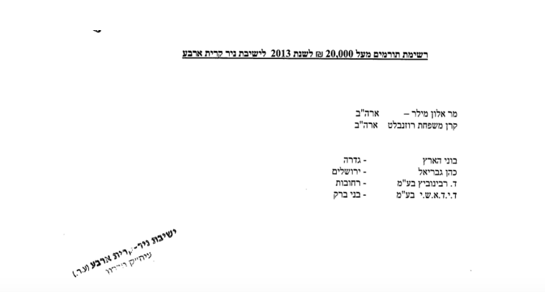
Others, such as the Bnei David pre-military academy in the settlement of Eli, don’t publish the names of some of their donors at all. In 2013, for example, the academy received 1.8 million Shekels from a mysterious "Donor in Brazil". 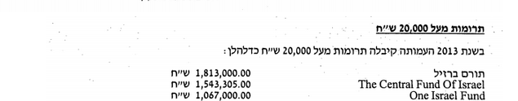
In 2010 many of that organization's donors remained anonymous and included “Donor from Tel Aviv,” “Donor from New York,” and so on.
Lior Shtull, CEO of the academy, explained in a phone call that the organization is not trying to hide anything. “Some donors seek to remain anonymous and we respect it," he said. "We follow the rules of Israel’s Non-profit Registrar and we get the annual approval for proper management. Trust me, if they had a problem with us we would have known.”
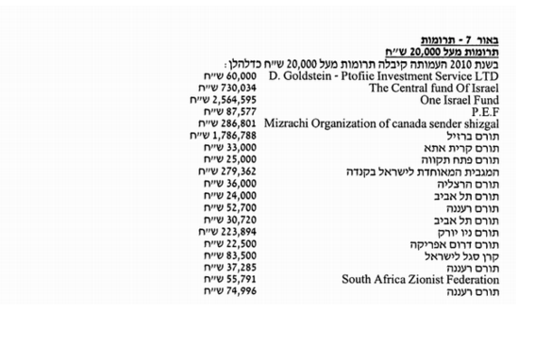

By comparison, Haaretz found that left-wing organizations, which are more heavily scrutinized, tend to be more transparent, like the rights group B'Tselem, which regularly publishes its list of donors. http://www.guidestar.org.il/sites/guidestar.org.il/files/vol/other/3295/2013%20Audit%20Hebrew.pdf
Secret donors' lists
Non-profits may ask Israel’s Registrar for Non-profit Organizations to waive the obligation to publish their donors' lists. Permission not to disclose the name of a donor is given for a specific donation in a particular year – and does not entitle the non-profit to forever hide its sources of income.
Member of Knesset Zehava Galon, from the left-wing Meretz party, recently approached the Registrar asking to provide her the list of organizations that were granted that privilege since the year 2010. Forty-three organizations appear on the list, some of them more than once as they were granted that privilege in different years.
Seven of the organizations on the list operate across the Green Line. They include a religious women's school in the settlement of Efrat; a yeshiva in Beit El; “The Fund for the Development of the Zionist Idea,” which operates under the settlement group Amana; Yeshivat Ateret Yerushalaim in the Old City of Jerusalem; Yeshivat Har Bracha, located in a settlement outside Nablus; a synagogue in the settlement of Immanuel and a yeshiva in Ma’aleh Adumim.
The list also includes organizations as diverse as Yad Leahim, which operates against Christian missionaries, assimilation and intermarriage; the Batsheva Dance Company; the Ma'aleh School of Television, Film and Arts in Jerusalem and the Adi Foundation, a charity founded by Israeli Ambassador to the U.S. Ron Dermer to commemorate his late wife. The list includes only two liberal political organizations - The Abraham Fund Initiatives, working to promote coexistence between Israel's Jewish and Arab citizens, and Signing Anew, which aims to promote democratic values in Israel.
Some organizations that were permitted not to reveal their donors in the past still fail to do so, apparently without permission, as they do not appear on the list of exempted groups.
In response to a request for comment, the Registrar wrote that every year it examines documents from 15,000 active non-profits.
"Due to the extent of the work, the examination is generic and focuses on checking that the non-profits have filed all the documents required by law," it said in a statement.
"Deeper checks into the content of the documents are conducted only as part of audits initiated by the Registrar or when complaints are filed against a non-profit." The Registrar added that it conducts 250 such audits annually and checks 1,000 complaints, following up with the organizations based on the findings of its probes.
Know the Other Side
The criticism of left-wing groups in Israel has led to a growing interest in the sources of funding of the opposing political side. Haaretz is aware of at least two liberal organizations in the U.S. and some in Israel that have conducted surveys into the funding of right-wing groups in Israel.
The media has also taken an interest in the subject, with a comprehensive report on the topic published in the New York Times five years ago http://www.nytimes.com/2010/07/06/world/middleeast/06settle.html?_r=0 . The data available at the time indicated that settlements in the occupied territories had received some $200 million in foreign funding between the years 2000 and 2010. Haaretz's own recent investigation into U.S. donations to pro-settlement groups shows that the flow of money has increased dramatically since then. A review of U.S. tax filings reveal that American non-profits transferred at least $224 million to settlement groups in Israel just between 2009 and 2013.
Reporting for this story was supported by a grant from the Pulitzer Center on Crisis Reporting http://pulitzercenter.org/

