Go to the profile of Laura Kasinof

[Laura Kasinof](https://latterly.org/@kasinof?source=post_header_lockup)

author of Don't be Afraid of the Bullets: An Accidental War Correspondent in Yemen. former NYT Sanaa. Latterly writer. Berlin-based. @pulitzercenter grantee.

2 days ago4 min read

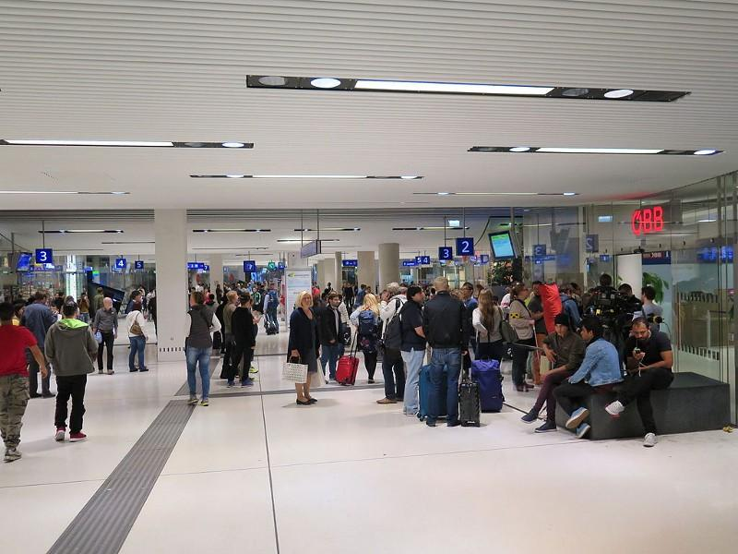

# **Being a refugee in Europe means joy, anxiety and nasty looks from the locals**

## **Living in Europe, it’s not difficult to witness the refugee experience.**

BERLIN

Around this time last year, Berlin’s drab, sardine can of an airport, Tegel, had become the scene for passing, yet powerful moments of pure joy.

I was on a plane from Athens and as we were landing at Tegel, I noticed a family across from me was growing nervous with excitement. During the flight, I had heard the mother and her two young children speaking together in Levantine Arabic, but I didn’t give it much thought. As we were descending, though, the family’s giddiness was palpable. Their faces pressed against the window. The mother had to quiet her children, but then the flight attendants had to settle the mother after she popped up to grab her bag from the overhead compartment as soon as the plane’s wheels touched ground.

At baggage claim, the whole family was squinting to see through translucent windows into the rest of the airport. When the exit, an automatic sliding door, opened, they craned their heads for a peek into the arrivals area. “There he is,” one child said. “There’s *Baba*.”

How long had this father been separated from his family?

Out of baggage claim and in the main hall the family reunited. I tried not to stare. There were hugs and kisses, but nothing too ostentatious, as if they were aware that they were still outsiders in a strange land, that they had to tread carefully, that the real joy of a family reunited would come in the hours and days to follow.

[Ex-NYT reporter Laura Kasinof joins Latterly as contributing writer](https://latterly.org/ex-nyt-reporter-laura-kasinof-joins-latterly-as-contributing-writer-4dd13dd1f208)

[We’re excited to announce that Laura Kasinof, whose war reporting during Yemen’s Arab Spring became the basis of her…latterly.org](https://latterly.org/ex-nyt-reporter-laura-kasinof-joins-latterly-as-contributing-writer-4dd13dd1f208)

Germany has a policy in which one member of a family can come to Germany, declare asylum, and then the rest of the immediate family will be allowed to join, otherwise known as family reunification visas. I believed that to be the case with this Syrian family based on what I saw. Often, a father would travel to Europe via the smugglers’ route, across the Mediterranean and northward, and then obtain visas for the rest of his family. Now, the number of new family reunification visas has [been limited](http://www.politico.eu/article/germany-toughens-refugee-policy-gabriel-merkel-asylum-seekers-family-reunification/). I hardly hear of or see these stories anymore.

Throughout the past year in Europe, and especially Berlin, encounters with asylum seekers on public transportation, or at airports and train stations has become routine. Sometimes they are delightful and other times heartbreaking.

On an empty city bus in Berlin one evening, a half dozen Syrian adolescents commandeered the rear section of the bus. They started tapping out Middle Eastern drum rhythms on the railings and seats. Two sang a traditional Arabic melody. The others would take turns getting up to dance, only to be knocked over with the sway of the bus. Everyone would laugh and take a half minute before regaining composure to start again. Occasionally a German couple would look back and give the boys a menacing stare, but it was of no use. The boys were in their own world. I was lucky enough to have been sitting close to them. They were good kids.

Not long thereafter, I was back at Tegel Airport, sitting near my plane’s gate early in the morning. Police entered the hall. They did a lap, monitoring passengers with intense gazes. Then they moved to their target, the only non-white person in the departure area. The police took the Arab-looking man aside, checked his documents over again. They let him go after about 10 minutes. Meanwhile I flew to Copenhagen without ever having to show an ID. I’m an immigrant in Europe, too.

On buses and trains at Europe’s borders, police often board, only checking the brown and black passengers’ documents. The Schengen zone was supposed to be about borderless travel, but that only depends on which passport one happens to be carrying. I’ve seen Africans and Arabs pulled off buses, not sure what happens to them next.

I was recently talking to a Syrian refugee teenager in Spain. He wants to take a bus to Germany just to visit his family. He knows he has to live in Spain because that is where he is registered as an asylum seeker. I told him that the borders are no longer open for people who look Syrian. He joked that his sister would make it through because of her fair complexion. As for him, he said the worst thing that would happen to him if caught crossing borders is that he would be sent back to Spain. I asked him if he was sure, and he shrugged and said he thought he was.



[Become a member today](https://latterly.org/memberships-f7e9555b3854#.923xf0pwh) and receive a free copy of her book, Don’t Be Afraid of the Bullets.

*Laura Kasinof is a Latterly contributing writer. Her reporting on refugees and migration is supported by the Pulitzer Center on Crisis Supporting.*